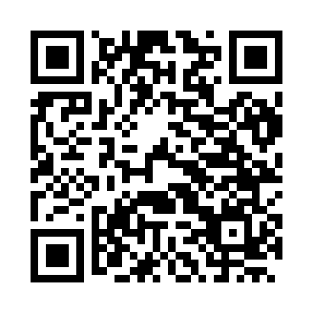
Prayer times for Loiseliere, France
Wed 1 May 2024 - Fri 31 May 2024
High Latitude Method: Angle Based Rule
Prayer Calculation Method: Islamic Organisations Union of France
Asar Calculation Method: Shafi

Date | Day | Fajr | Sunrise | Dhuhr | Asr | Maghrib | Isha
1 | Wed | 5:13 | 6:35 | 1:55 | 5:57 | 9:16 | 10:39
2 | Thu | 5:11 | 6:34 | 1:55 | 5:57 | 9:18 | 10:41
3 | Fri | 5:09 | 6:32 | 1:55 | 5:58 | 9:19 | 10:43
4 | Sat | 5:06 | 6:30 | 1:55 | 5:58 | 9:21 | 10:45
5 | Sun | 5:04 | 6:29 | 1:55 | 5:59 | 9:22 | 10:47
6 | Mon | 5:02 | 6:27 | 1:55 | 5:59 | 9:24 | 10:49
7 | Tue | 5:00 | 6:25 | 1:55 | 6:00 | 9:25 | 10:51
8 | Wed | 4:58 | 6:24 | 1:55 | 6:01 | 9:27 | 10:53
9 | Thu | 4:55 | 6:22 | 1:55 | 6:01 | 9:28 | 10:55
10 | Fri | 4:53 | 6:21 | 1:55 | 6:02 | 9:30 | 10:57
11 | Sat | 4:51 | 6:19 | 1:55 | 6:02 | 9:31 | 11:00
12 | Sun | 4:49 | 6:18 | 1:55 | 6:03 | 9:33 | 11:02
13 | Mon | 4:47 | 6:16 | 1:55 | 6:03 | 9:34 | 11:04
14 | Tue | 4:45 | 6:15 | 1:55 | 6:04 | 9:35 | 11:06
15 | Wed | 4:43 | 6:14 | 1:55 | 6:04 | 9:37 | 11:08
16 | Thu | 4:41 | 6:12 | 1:55 | 6:05 | 9:38 | 11:10
17 | Fri | 4:39 | 6:11 | 1:55 | 6:05 | 9:39 | 11:12
18 | Sat | 4:37 | 6:10 | 1:55 | 6:06 | 9:41 | 11:14
19 | Sun | 4:35 | 6:09 | 1:55 | 6:06 | 9:42 | 11:15
20 | Mon | 4:34 | 6:07 | 1:55 | 6:07 | 9:43 | 11:17
21 | Tue | 4:32 | 6:06 | 1:55 | 6:07 | 9:45 | 11:19
22 | Wed | 4:30 | 6:05 | 1:55 | 6:08 | 9:46 | 11:21
23 | Thu | 4:28 | 6:04 | 1:55 | 6:08 | 9:47 | 11:23
24 | Fri | 4:27 | 6:03 | 1:55 | 6:09 | 9:48 | 11:25
25 | Sat | 4:25 | 6:02 | 1:55 | 6:09 | 9:50 | 11:27
26 | Sun | 4:23 | 6:01 | 1:56 | 6:10 | 9:51 | 11:29
27 | Mon | 4:22 | 6:00 | 1:56 | 6:10 | 9:52 | 11:29
28 | Tue | 4:22 | 5:59 | 1:56 | 6:11 | 9:53 | 11:30
29 | Wed | 4:21 | 5:58 | 1:56 | 6:11 | 9:54 | 11:31
30 | Thu | 4:21 | 5:58 | 1:56 | 6:12 | 9:55 | 11:32
31 | Fri | 4:21 | 5:57 | 1:56 | 6:12 | 9:56 | 11:32
Prayer times provided by https://www.salahtimes.com

