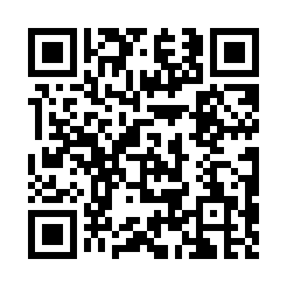
Prayer times for Oyster Bay Cove, New York, USA
Mon 1 Jul 2024 - Wed 31 Jul 2024
High Latitude Method: Angle Based Rule
Prayer Calculation Method: Islamic Society of North America
Asar Calculation Method: Shafi

Date | Day | Fajr | Sunrise | Dhuhr | Asr | Maghrib | Isha
1 | Mon | 3:47 | 5:26 | 12:58 | 4:58 | 8:30 | 10:09
2 | Tue | 3:48 | 5:27 | 12:58 | 4:58 | 8:29 | 10:08
3 | Wed | 3:48 | 5:28 | 12:58 | 4:59 | 8:29 | 10:08
4 | Thu | 3:49 | 5:28 | 12:59 | 4:59 | 8:29 | 10:08
5 | Fri | 3:50 | 5:29 | 12:59 | 4:59 | 8:29 | 10:07
6 | Sat | 3:51 | 5:29 | 12:59 | 4:59 | 8:28 | 10:07
7 | Sun | 3:52 | 5:30 | 12:59 | 4:59 | 8:28 | 10:06
8 | Mon | 3:53 | 5:31 | 12:59 | 4:59 | 8:28 | 10:05
9 | Tue | 3:54 | 5:31 | 12:59 | 4:59 | 8:27 | 10:05
10 | Wed | 3:55 | 5:32 | 1:00 | 4:59 | 8:27 | 10:04
11 | Thu | 3:56 | 5:33 | 1:00 | 4:59 | 8:26 | 10:03
12 | Fri | 3:57 | 5:33 | 1:00 | 4:59 | 8:26 | 10:02
13 | Sat | 3:58 | 5:34 | 1:00 | 4:59 | 8:25 | 10:01
14 | Sun | 3:59 | 5:35 | 1:00 | 4:59 | 8:25 | 10:00
15 | Mon | 4:00 | 5:36 | 1:00 | 4:59 | 8:24 | 10:00
16 | Tue | 4:01 | 5:37 | 1:00 | 4:59 | 8:24 | 9:59
17 | Wed | 4:02 | 5:37 | 1:00 | 4:59 | 8:23 | 9:57
18 | Thu | 4:04 | 5:38 | 1:00 | 4:59 | 8:22 | 9:56
19 | Fri | 4:05 | 5:39 | 1:00 | 4:58 | 8:21 | 9:55
20 | Sat | 4:06 | 5:40 | 1:00 | 4:58 | 8:21 | 9:54
21 | Sun | 4:07 | 5:41 | 1:01 | 4:58 | 8:20 | 9:53
22 | Mon | 4:09 | 5:42 | 1:01 | 4:58 | 8:19 | 9:52
23 | Tue | 4:10 | 5:43 | 1:01 | 4:58 | 8:18 | 9:51
24 | Wed | 4:11 | 5:43 | 1:01 | 4:57 | 8:17 | 9:49
25 | Thu | 4:13 | 5:44 | 1:01 | 4:57 | 8:16 | 9:48
26 | Fri | 4:14 | 5:45 | 1:01 | 4:57 | 8:15 | 9:47
27 | Sat | 4:15 | 5:46 | 1:01 | 4:57 | 8:14 | 9:45
28 | Sun | 4:16 | 5:47 | 1:01 | 4:56 | 8:14 | 9:44
29 | Mon | 4:18 | 5:48 | 1:01 | 4:56 | 8:12 | 9:43
30 | Tue | 4:19 | 5:49 | 1:00 | 4:56 | 8:11 | 9:41
31 | Wed | 4:20 | 5:50 | 1:00 | 4:55 | 8:10 | 9:40
Prayer times provided by https://www.salahtimes.com

