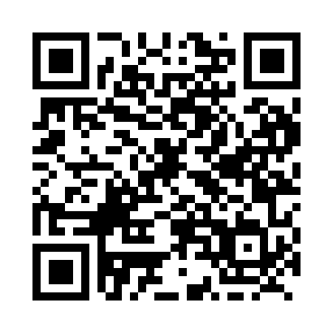

**Prayer times for Ksituan, Alberta, Canada**

**Sun 1 Sep 2024 - Mon 30 Sep 2024**

**High Latitude Method: Angle Based Rule**

**Prayer Calculation Method: Islamic Society of North America**

**Asar Calculation Method: Hanafi**

|  |  |  |  |  |  |  |  |
| --- | --- | --- | --- | --- | --- | --- | --- |
| **Date** | **Day** | **Fajr** | **Sunrise** | **Dhuhr** | **Asr** | **Maghrib** | **Isha** |
| 1 | Sun | 5:07 | 7:02 | 1:56 | 6:35 | 8:48 | 10:43 |
| 2 | Mon | 5:09 | 7:04 | 1:55 | 6:33 | 8:46 | 10:40 |
| 3 | Tue | 5:12 | 7:06 | 1:55 | 6:31 | 8:43 | 10:37 |
| 4 | Wed | 5:15 | 7:08 | 1:55 | 6:29 | 8:41 | 10:33 |
| 5 | Thu | 5:18 | 7:10 | 1:54 | 6:26 | 8:38 | 10:30 |
| 6 | Fri | 5:20 | 7:12 | 1:54 | 6:24 | 8:35 | 10:27 |
| 7 | Sat | 5:23 | 7:14 | 1:54 | 6:22 | 8:33 | 10:23 |
| 8 | Sun | 5:25 | 7:16 | 1:53 | 6:20 | 8:30 | 10:20 |
| 9 | Mon | 5:28 | 7:18 | 1:53 | 6:18 | 8:28 | 10:17 |
| 10 | Tue | 5:30 | 7:19 | 1:53 | 6:16 | 8:25 | 10:14 |
| 11 | Wed | 5:33 | 7:21 | 1:52 | 6:14 | 8:22 | 10:10 |
| 12 | Thu | 5:35 | 7:23 | 1:52 | 6:12 | 8:20 | 10:07 |
| 13 | Fri | 5:38 | 7:25 | 1:52 | 6:10 | 8:17 | 10:04 |
| 14 | Sat | 5:40 | 7:27 | 1:51 | 6:07 | 8:14 | 10:01 |
| 15 | Sun | 5:43 | 7:29 | 1:51 | 6:05 | 8:12 | 9:58 |
| 16 | Mon | 5:45 | 7:31 | 1:51 | 6:03 | 8:09 | 9:55 |
| 17 | Tue | 5:47 | 7:33 | 1:50 | 6:01 | 8:06 | 9:52 |
| 18 | Wed | 5:50 | 7:35 | 1:50 | 5:59 | 8:04 | 9:49 |
| 19 | Thu | 5:52 | 7:37 | 1:50 | 5:56 | 8:01 | 9:46 |
| 20 | Fri | 5:54 | 7:39 | 1:49 | 5:54 | 7:58 | 9:43 |
| 21 | Sat | 5:56 | 7:41 | 1:49 | 5:52 | 7:56 | 9:40 |
| 22 | Sun | 5:59 | 7:43 | 1:48 | 5:50 | 7:53 | 9:37 |
| 23 | Mon | 6:01 | 7:45 | 1:48 | 5:47 | 7:50 | 9:34 |
| 24 | Tue | 6:03 | 7:47 | 1:48 | 5:45 | 7:48 | 9:31 |
| 25 | Wed | 6:05 | 7:49 | 1:47 | 5:43 | 7:45 | 9:28 |
| 26 | Thu | 6:07 | 7:51 | 1:47 | 5:41 | 7:42 | 9:25 |
| 27 | Fri | 6:10 | 7:53 | 1:47 | 5:38 | 7:40 | 9:23 |
| 28 | Sat | 6:12 | 7:54 | 1:46 | 5:36 | 7:37 | 9:20 |
| 29 | Sun | 6:14 | 7:56 | 1:46 | 5:34 | 7:35 | 9:17 |
| 30 | Mon | 6:16 | 7:58 | 1:46 | 5:31 | 7:32 | 9:14 |

**Prayer times provided by https://www.salahtimes.com**