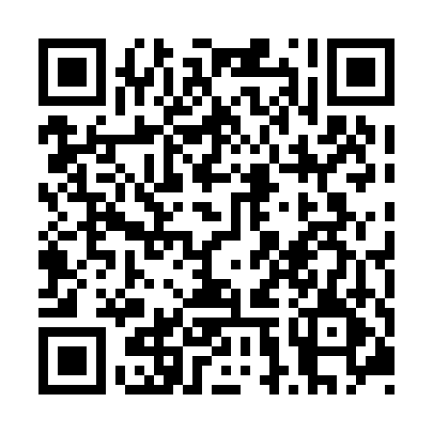
Prayer times for Saint-Juste-du-Lac, Quebec, Canada
Mon 1 Jul 2024 - Wed 31 Jul 2024
High Latitude Method: Angle Based Rule
Prayer Calculation Method: Islamic Society of North America
Asar Calculation Method: Hanafi

Date | Day | Fajr | Sunrise | Dhuhr | Asr | Maghrib | Isha
1 | Mon | 2:40 | 4:42 | 12:39 | 6:07 | 8:36 | 10:38
2 | Tue | 2:41 | 4:42 | 12:39 | 6:06 | 8:36 | 10:38
3 | Wed | 2:41 | 4:43 | 12:39 | 6:06 | 8:36 | 10:37
4 | Thu | 2:41 | 4:44 | 12:40 | 6:06 | 8:35 | 10:37
5 | Fri | 2:42 | 4:44 | 12:40 | 6:06 | 8:35 | 10:37
6 | Sat | 2:42 | 4:45 | 12:40 | 6:06 | 8:34 | 10:37
7 | Sun | 2:43 | 4:46 | 12:40 | 6:06 | 8:34 | 10:37
8 | Mon | 2:43 | 4:47 | 12:40 | 6:06 | 8:33 | 10:37
9 | Tue | 2:44 | 4:48 | 12:40 | 6:05 | 8:33 | 10:36
10 | Wed | 2:44 | 4:48 | 12:41 | 6:05 | 8:32 | 10:36
11 | Thu | 2:45 | 4:49 | 12:41 | 6:05 | 8:32 | 10:36
12 | Fri | 2:46 | 4:50 | 12:41 | 6:04 | 8:31 | 10:35
13 | Sat | 2:48 | 4:51 | 12:41 | 6:04 | 8:30 | 10:33
14 | Sun | 2:49 | 4:52 | 12:41 | 6:04 | 8:29 | 10:32
15 | Mon | 2:51 | 4:53 | 12:41 | 6:03 | 8:28 | 10:30
16 | Tue | 2:53 | 4:54 | 12:41 | 6:03 | 8:28 | 10:28
17 | Wed | 2:55 | 4:55 | 12:41 | 6:02 | 8:27 | 10:27
18 | Thu | 2:57 | 4:56 | 12:41 | 6:02 | 8:26 | 10:25
19 | Fri | 2:59 | 4:58 | 12:41 | 6:01 | 8:25 | 10:23
20 | Sat | 3:01 | 4:59 | 12:41 | 6:01 | 8:24 | 10:21
21 | Sun | 3:03 | 5:00 | 12:41 | 6:00 | 8:23 | 10:19
22 | Mon | 3:05 | 5:01 | 12:42 | 6:00 | 8:22 | 10:17
23 | Tue | 3:07 | 5:02 | 12:42 | 5:59 | 8:20 | 10:15
24 | Wed | 3:09 | 5:03 | 12:42 | 5:58 | 8:19 | 10:13
25 | Thu | 3:11 | 5:04 | 12:42 | 5:58 | 8:18 | 10:11
26 | Fri | 3:13 | 5:06 | 12:42 | 5:57 | 8:17 | 10:09
27 | Sat | 3:15 | 5:07 | 12:42 | 5:56 | 8:16 | 10:07
28 | Sun | 3:17 | 5:08 | 12:42 | 5:55 | 8:14 | 10:05
29 | Mon | 3:19 | 5:09 | 12:41 | 5:55 | 8:13 | 10:03
30 | Tue | 3:21 | 5:11 | 12:41 | 5:54 | 8:12 | 10:01
31 | Wed | 3:23 | 5:12 | 12:41 | 5:53 | 8:10 | 9:59
Prayer times provided by https://www.salahtimes.com

