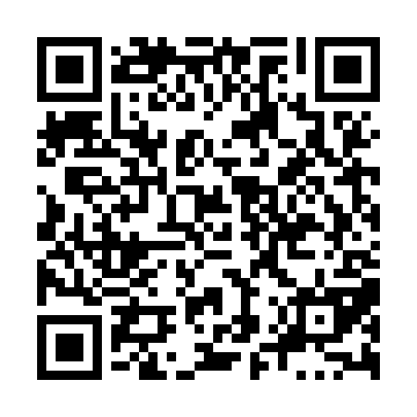
Prayer times for English Harbour, Newfoundland and Labrador, Canada
Mon 1 Jul 2024 - Wed 31 Jul 2024
High Latitude Method: Angle Based Rule
Prayer Calculation Method: Islamic Society of North America
Asar Calculation Method: Hanafi

Date | Day | Fajr | Sunrise | Dhuhr | Asr | Maghrib | Isha
1 | Mon | 3:07 | 5:06 | 1:07 | 6:36 | 9:08 | 11:07
2 | Tue | 3:07 | 5:07 | 1:07 | 6:36 | 9:07 | 11:07
3 | Wed | 3:07 | 5:08 | 1:07 | 6:36 | 9:07 | 11:07
4 | Thu | 3:08 | 5:08 | 1:08 | 6:36 | 9:07 | 11:07
5 | Fri | 3:08 | 5:09 | 1:08 | 6:36 | 9:06 | 11:07
6 | Sat | 3:09 | 5:10 | 1:08 | 6:36 | 9:06 | 11:07
7 | Sun | 3:09 | 5:11 | 1:08 | 6:35 | 9:05 | 11:07
8 | Mon | 3:10 | 5:12 | 1:08 | 6:35 | 9:05 | 11:06
9 | Tue | 3:10 | 5:12 | 1:08 | 6:35 | 9:04 | 11:06
10 | Wed | 3:11 | 5:13 | 1:09 | 6:35 | 9:03 | 11:06
11 | Thu | 3:11 | 5:14 | 1:09 | 6:34 | 9:03 | 11:06
12 | Fri | 3:12 | 5:15 | 1:09 | 6:34 | 9:02 | 11:05
13 | Sat | 3:12 | 5:16 | 1:09 | 6:34 | 9:01 | 11:05
14 | Sun | 3:13 | 5:17 | 1:09 | 6:33 | 9:00 | 11:05
15 | Mon | 3:14 | 5:18 | 1:09 | 6:33 | 8:59 | 11:04
16 | Tue | 3:14 | 5:19 | 1:09 | 6:32 | 8:59 | 11:04
17 | Wed | 3:16 | 5:20 | 1:09 | 6:32 | 8:58 | 11:02
18 | Thu | 3:18 | 5:22 | 1:09 | 6:31 | 8:57 | 11:00
19 | Fri | 3:20 | 5:23 | 1:09 | 6:31 | 8:56 | 10:58
20 | Sat | 3:22 | 5:24 | 1:09 | 6:30 | 8:55 | 10:56
21 | Sun | 3:24 | 5:25 | 1:10 | 6:30 | 8:53 | 10:54
22 | Mon | 3:26 | 5:26 | 1:10 | 6:29 | 8:52 | 10:52
23 | Tue | 3:28 | 5:27 | 1:10 | 6:28 | 8:51 | 10:50
24 | Wed | 3:30 | 5:29 | 1:10 | 6:28 | 8:50 | 10:48
25 | Thu | 3:32 | 5:30 | 1:10 | 6:27 | 8:49 | 10:46
26 | Fri | 3:35 | 5:31 | 1:10 | 6:26 | 8:47 | 10:43
27 | Sat | 3:37 | 5:32 | 1:10 | 6:25 | 8:46 | 10:41
28 | Sun | 3:39 | 5:34 | 1:10 | 6:25 | 8:45 | 10:39
29 | Mon | 3:41 | 5:35 | 1:10 | 6:24 | 8:44 | 10:37
30 | Tue | 3:43 | 5:36 | 1:09 | 6:23 | 8:42 | 10:35
31 | Wed | 3:45 | 5:37 | 1:09 | 6:22 | 8:41 | 10:32
Prayer times provided by https://www.salahtimes.com

