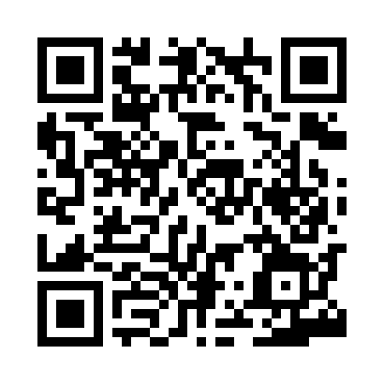

**Prayer times for Alslev, Denmark**

**Sun 1 Sep 2024 - Mon 30 Sep 2024**

**High Latitude Method: Angle Based Rule**

**Prayer Calculation Method: Muslim World League**

**Asar Calculation Method: Hanafi**

|  |  |  |  |  |  |  |  |
| --- | --- | --- | --- | --- | --- | --- | --- |
| **Date** | **Day** | **Fajr** | **Sunrise** | **Dhuhr** | **Asr** | **Maghrib** | **Isha** |
| 1 | Sun | 4:08 | 6:32 | 1:26 | 6:06 | 8:19 | 10:32 |
| 2 | Mon | 4:11 | 6:34 | 1:26 | 6:04 | 8:16 | 10:28 |
| 3 | Tue | 4:15 | 6:36 | 1:26 | 6:02 | 8:14 | 10:25 |
| 4 | Wed | 4:18 | 6:38 | 1:25 | 6:00 | 8:11 | 10:21 |
| 5 | Thu | 4:21 | 6:40 | 1:25 | 5:58 | 8:09 | 10:18 |
| 6 | Fri | 4:24 | 6:42 | 1:25 | 5:56 | 8:06 | 10:14 |
| 7 | Sat | 4:26 | 6:44 | 1:24 | 5:53 | 8:04 | 10:11 |
| 8 | Sun | 4:29 | 6:46 | 1:24 | 5:51 | 8:01 | 10:08 |
| 9 | Mon | 4:32 | 6:48 | 1:23 | 5:49 | 7:58 | 10:04 |
| 10 | Tue | 4:35 | 6:49 | 1:23 | 5:47 | 7:56 | 10:01 |
| 11 | Wed | 4:38 | 6:51 | 1:23 | 5:45 | 7:53 | 9:57 |
| 12 | Thu | 4:40 | 6:53 | 1:22 | 5:43 | 7:50 | 9:54 |
| 13 | Fri | 4:43 | 6:55 | 1:22 | 5:41 | 7:48 | 9:51 |
| 14 | Sat | 4:46 | 6:57 | 1:22 | 5:39 | 7:45 | 9:48 |
| 15 | Sun | 4:48 | 6:59 | 1:21 | 5:37 | 7:43 | 9:45 |
| 16 | Mon | 4:51 | 7:01 | 1:21 | 5:34 | 7:40 | 9:41 |
| 17 | Tue | 4:53 | 7:03 | 1:21 | 5:32 | 7:37 | 9:38 |
| 18 | Wed | 4:56 | 7:05 | 1:20 | 5:30 | 7:35 | 9:35 |
| 19 | Thu | 4:58 | 7:07 | 1:20 | 5:28 | 7:32 | 9:32 |
| 20 | Fri | 5:01 | 7:09 | 1:20 | 5:26 | 7:29 | 9:29 |
| 21 | Sat | 5:03 | 7:10 | 1:19 | 5:23 | 7:27 | 9:26 |
| 22 | Sun | 5:05 | 7:12 | 1:19 | 5:21 | 7:24 | 9:23 |
| 23 | Mon | 5:08 | 7:14 | 1:19 | 5:19 | 7:22 | 9:20 |
| 24 | Tue | 5:10 | 7:16 | 1:18 | 5:17 | 7:19 | 9:17 |
| 25 | Wed | 5:12 | 7:18 | 1:18 | 5:14 | 7:16 | 9:14 |
| 26 | Thu | 5:15 | 7:20 | 1:17 | 5:12 | 7:14 | 9:11 |
| 27 | Fri | 5:17 | 7:22 | 1:17 | 5:10 | 7:11 | 9:08 |
| 28 | Sat | 5:19 | 7:24 | 1:17 | 5:08 | 7:09 | 9:05 |
| 29 | Sun | 5:21 | 7:26 | 1:16 | 5:05 | 7:06 | 9:02 |
| 30 | Mon | 5:24 | 7:28 | 1:16 | 5:03 | 7:03 | 9:00 |

**Prayer times provided by https://www.salahtimes.com**