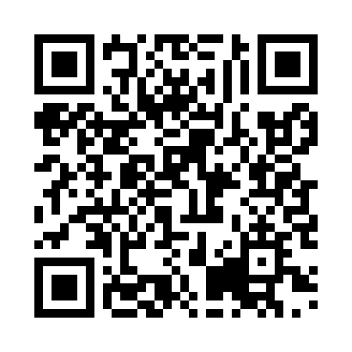
Prayer times for Tosashimizu, Japan
Wed 1 May 2024 - Fri 31 May 2024
High Latitude Method: None
Prayer Calculation Method: Muslim World League
Asar Calculation Method: Shafi

Date | Day | Fajr | Sunrise | Dhuhr | Asr | Maghrib | Isha
1 | Wed | 3:51 | 5:21 | 12:06 | 3:46 | 6:50 | 8:15
2 | Thu | 3:49 | 5:20 | 12:05 | 3:47 | 6:51 | 8:16
3 | Fri | 3:48 | 5:19 | 12:05 | 3:47 | 6:52 | 8:17
4 | Sat | 3:47 | 5:18 | 12:05 | 3:47 | 6:53 | 8:18
5 | Sun | 3:46 | 5:17 | 12:05 | 3:47 | 6:53 | 8:19
6 | Mon | 3:45 | 5:17 | 12:05 | 3:47 | 6:54 | 8:20
7 | Tue | 3:43 | 5:16 | 12:05 | 3:47 | 6:55 | 8:21
8 | Wed | 3:42 | 5:15 | 12:05 | 3:47 | 6:55 | 8:22
9 | Thu | 3:41 | 5:14 | 12:05 | 3:47 | 6:56 | 8:24
10 | Fri | 3:40 | 5:13 | 12:05 | 3:47 | 6:57 | 8:25
11 | Sat | 3:39 | 5:12 | 12:05 | 3:47 | 6:58 | 8:26
12 | Sun | 3:38 | 5:12 | 12:05 | 3:47 | 6:58 | 8:27
13 | Mon | 3:37 | 5:11 | 12:05 | 3:47 | 6:59 | 8:28
14 | Tue | 3:36 | 5:10 | 12:05 | 3:47 | 7:00 | 8:29
15 | Wed | 3:35 | 5:09 | 12:05 | 3:47 | 7:01 | 8:30
16 | Thu | 3:34 | 5:09 | 12:05 | 3:47 | 7:01 | 8:31
17 | Fri | 3:33 | 5:08 | 12:05 | 3:47 | 7:02 | 8:32
18 | Sat | 3:32 | 5:08 | 12:05 | 3:47 | 7:03 | 8:33
19 | Sun | 3:31 | 5:07 | 12:05 | 3:47 | 7:03 | 8:33
20 | Mon | 3:30 | 5:06 | 12:05 | 3:47 | 7:04 | 8:34
21 | Tue | 3:29 | 5:06 | 12:05 | 3:47 | 7:05 | 8:35
22 | Wed | 3:28 | 5:05 | 12:05 | 3:48 | 7:05 | 8:36
23 | Thu | 3:27 | 5:05 | 12:05 | 3:48 | 7:06 | 8:37
24 | Fri | 3:27 | 5:04 | 12:05 | 3:48 | 7:07 | 8:38
25 | Sat | 3:26 | 5:04 | 12:05 | 3:48 | 7:07 | 8:39
26 | Sun | 3:25 | 5:03 | 12:06 | 3:48 | 7:08 | 8:40
27 | Mon | 3:25 | 5:03 | 12:06 | 3:48 | 7:09 | 8:41
28 | Tue | 3:24 | 5:03 | 12:06 | 3:48 | 7:09 | 8:42
29 | Wed | 3:23 | 5:02 | 12:06 | 3:48 | 7:10 | 8:43
30 | Thu | 3:23 | 5:02 | 12:06 | 3:49 | 7:11 | 8:43
31 | Fri | 3:22 | 5:02 | 12:06 | 3:49 | 7:11 | 8:44
Prayer times provided by https://www.salahtimes.com

