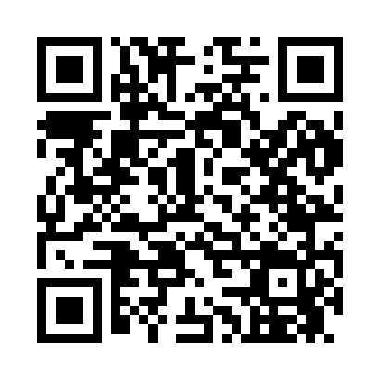
Prayer times for Fort Spokane, Washington, USA
Mon 1 Jul 2024 - Wed 31 Jul 2024
High Latitude Method: Angle Based Rule
Prayer Calculation Method: Islamic Society of North America
Asar Calculation Method: Shafi

Date | Day | Fajr | Sunrise | Dhuhr | Asr | Maghrib | Isha
1 | Mon | 2:58 | 4:59 | 12:57 | 5:12 | 8:56 | 10:56
2 | Tue | 2:58 | 4:59 | 12:57 | 5:12 | 8:55 | 10:56
3 | Wed | 2:59 | 5:00 | 12:58 | 5:12 | 8:55 | 10:56
4 | Thu | 2:59 | 5:01 | 12:58 | 5:12 | 8:55 | 10:56
5 | Fri | 3:00 | 5:02 | 12:58 | 5:12 | 8:54 | 10:56
6 | Sat | 3:00 | 5:02 | 12:58 | 5:12 | 8:54 | 10:56
7 | Sun | 3:01 | 5:03 | 12:58 | 5:12 | 8:53 | 10:56
8 | Mon | 3:01 | 5:04 | 12:58 | 5:12 | 8:53 | 10:55
9 | Tue | 3:02 | 5:05 | 12:59 | 5:12 | 8:52 | 10:55
10 | Wed | 3:02 | 5:06 | 12:59 | 5:12 | 8:51 | 10:55
11 | Thu | 3:03 | 5:07 | 12:59 | 5:12 | 8:51 | 10:55
12 | Fri | 3:03 | 5:08 | 12:59 | 5:11 | 8:50 | 10:54
13 | Sat | 3:04 | 5:09 | 12:59 | 5:11 | 8:49 | 10:54
14 | Sun | 3:05 | 5:10 | 12:59 | 5:11 | 8:48 | 10:52
15 | Mon | 3:07 | 5:11 | 12:59 | 5:11 | 8:48 | 10:50
16 | Tue | 3:09 | 5:12 | 12:59 | 5:11 | 8:47 | 10:49
17 | Wed | 3:11 | 5:13 | 12:59 | 5:10 | 8:46 | 10:47
18 | Thu | 3:13 | 5:14 | 1:00 | 5:10 | 8:45 | 10:45
19 | Fri | 3:15 | 5:15 | 1:00 | 5:10 | 8:44 | 10:43
20 | Sat | 3:17 | 5:16 | 1:00 | 5:09 | 8:43 | 10:41
21 | Sun | 3:19 | 5:17 | 1:00 | 5:09 | 8:42 | 10:39
22 | Mon | 3:21 | 5:18 | 1:00 | 5:09 | 8:41 | 10:38
23 | Tue | 3:23 | 5:20 | 1:00 | 5:08 | 8:39 | 10:36
24 | Wed | 3:25 | 5:21 | 1:00 | 5:08 | 8:38 | 10:34
25 | Thu | 3:27 | 5:22 | 1:00 | 5:08 | 8:37 | 10:32
26 | Fri | 3:29 | 5:23 | 1:00 | 5:07 | 8:36 | 10:29
27 | Sat | 3:31 | 5:24 | 1:00 | 5:07 | 8:35 | 10:27
28 | Sun | 3:33 | 5:26 | 1:00 | 5:06 | 8:33 | 10:25
29 | Mon | 3:35 | 5:27 | 1:00 | 5:06 | 8:32 | 10:23
30 | Tue | 3:37 | 5:28 | 1:00 | 5:05 | 8:30 | 10:21
31 | Wed | 3:39 | 5:29 | 1:00 | 5:05 | 8:29 | 10:19
Prayer times provided by https://www.salahtimes.com

