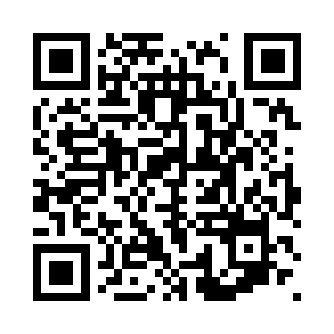
Prayer times for Bebe Ketti, Cameroon
Wed 1 May 2024 - Fri 31 May 2024
High Latitude Method: None
Prayer Calculation Method: Muslim World League
Asar Calculation Method: Shafi

Date | Day | Fajr | Sunrise | Dhuhr | Asr | Maghrib | Isha
1 | Wed | 4:52 | 6:04 | 12:15 | 3:32 | 6:26 | 7:34
2 | Thu | 4:51 | 6:04 | 12:15 | 3:32 | 6:26 | 7:34
3 | Fri | 4:51 | 6:03 | 12:14 | 3:32 | 6:26 | 7:34
4 | Sat | 4:50 | 6:03 | 12:14 | 3:33 | 6:26 | 7:34
5 | Sun | 4:50 | 6:03 | 12:14 | 3:33 | 6:26 | 7:34
6 | Mon | 4:50 | 6:03 | 12:14 | 3:33 | 6:26 | 7:34
7 | Tue | 4:49 | 6:02 | 12:14 | 3:34 | 6:26 | 7:35
8 | Wed | 4:49 | 6:02 | 12:14 | 3:34 | 6:26 | 7:35
9 | Thu | 4:49 | 6:02 | 12:14 | 3:34 | 6:26 | 7:35
10 | Fri | 4:49 | 6:02 | 12:14 | 3:35 | 6:26 | 7:35
11 | Sat | 4:48 | 6:02 | 12:14 | 3:35 | 6:26 | 7:36
12 | Sun | 4:48 | 6:02 | 12:14 | 3:35 | 6:26 | 7:36
13 | Mon | 4:48 | 6:01 | 12:14 | 3:36 | 6:27 | 7:36
14 | Tue | 4:47 | 6:01 | 12:14 | 3:36 | 6:27 | 7:36
15 | Wed | 4:47 | 6:01 | 12:14 | 3:36 | 6:27 | 7:37
16 | Thu | 4:47 | 6:01 | 12:14 | 3:37 | 6:27 | 7:37
17 | Fri | 4:47 | 6:01 | 12:14 | 3:37 | 6:27 | 7:37
18 | Sat | 4:47 | 6:01 | 12:14 | 3:37 | 6:27 | 7:37
19 | Sun | 4:46 | 6:01 | 12:14 | 3:38 | 6:28 | 7:38
20 | Mon | 4:46 | 6:01 | 12:14 | 3:38 | 6:28 | 7:38
21 | Tue | 4:46 | 6:01 | 12:14 | 3:38 | 6:28 | 7:38
22 | Wed | 4:46 | 6:01 | 12:14 | 3:38 | 6:28 | 7:38
23 | Thu | 4:46 | 6:01 | 12:14 | 3:39 | 6:28 | 7:39
24 | Fri | 4:46 | 6:01 | 12:15 | 3:39 | 6:28 | 7:39
25 | Sat | 4:46 | 6:01 | 12:15 | 3:39 | 6:29 | 7:39
26 | Sun | 4:45 | 6:01 | 12:15 | 3:40 | 6:29 | 7:40
27 | Mon | 4:45 | 6:01 | 12:15 | 3:40 | 6:29 | 7:40
28 | Tue | 4:45 | 6:01 | 12:15 | 3:40 | 6:29 | 7:40
29 | Wed | 4:45 | 6:01 | 12:15 | 3:41 | 6:30 | 7:41
30 | Thu | 4:45 | 6:01 | 12:15 | 3:41 | 6:30 | 7:41
31 | Fri | 4:45 | 6:01 | 12:15 | 3:41 | 6:30 | 7:41
Prayer times provided by https://www.salahtimes.com

