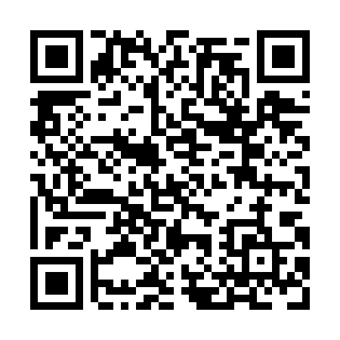
Prayer times for Fort Mackenzie, Quebec, Canada
Mon 1 Jul 2024 - Wed 31 Jul 2024
High Latitude Method: Angle Based Rule
Prayer Calculation Method: Islamic Society of North America
Asar Calculation Method: Hanafi

Date | Day | Fajr | Sunrise | Dhuhr | Asr | Maghrib | Isha
1 | Mon | 2:14 | 3:48 | 12:40 | 6:29 | 9:31 | 11:05
2 | Tue | 2:15 | 3:49 | 12:40 | 6:29 | 9:30 | 11:05
3 | Wed | 2:15 | 3:50 | 12:40 | 6:29 | 9:30 | 11:05
4 | Thu | 2:16 | 3:51 | 12:40 | 6:29 | 9:29 | 11:05
5 | Fri | 2:16 | 3:53 | 12:41 | 6:28 | 9:28 | 11:04
6 | Sat | 2:17 | 3:54 | 12:41 | 6:28 | 9:27 | 11:04
7 | Sun | 2:18 | 3:55 | 12:41 | 6:28 | 9:26 | 11:03
8 | Mon | 2:18 | 3:56 | 12:41 | 6:27 | 9:25 | 11:03
9 | Tue | 2:19 | 3:57 | 12:41 | 6:27 | 9:24 | 11:03
10 | Wed | 2:20 | 3:59 | 12:41 | 6:26 | 9:23 | 11:02
11 | Thu | 2:21 | 4:00 | 12:41 | 6:26 | 9:22 | 11:02
12 | Fri | 2:21 | 4:02 | 12:42 | 6:25 | 9:21 | 11:01
13 | Sat | 2:22 | 4:03 | 12:42 | 6:25 | 9:20 | 11:00
14 | Sun | 2:23 | 4:05 | 12:42 | 6:24 | 9:18 | 11:00
15 | Mon | 2:24 | 4:06 | 12:42 | 6:23 | 9:17 | 10:59
16 | Tue | 2:25 | 4:08 | 12:42 | 6:23 | 9:15 | 10:58
17 | Wed | 2:26 | 4:09 | 12:42 | 6:22 | 9:14 | 10:58
18 | Thu | 2:26 | 4:11 | 12:42 | 6:21 | 9:12 | 10:57
19 | Fri | 2:27 | 4:13 | 12:42 | 6:20 | 9:11 | 10:56
20 | Sat | 2:28 | 4:14 | 12:42 | 6:20 | 9:09 | 10:55
21 | Sun | 2:29 | 4:16 | 12:42 | 6:19 | 9:07 | 10:55
22 | Mon | 2:30 | 4:18 | 12:42 | 6:18 | 9:06 | 10:54
23 | Tue | 2:31 | 4:20 | 12:42 | 6:17 | 9:04 | 10:53
24 | Wed | 2:32 | 4:22 | 12:42 | 6:16 | 9:02 | 10:52
25 | Thu | 2:33 | 4:23 | 12:42 | 6:15 | 9:00 | 10:51
26 | Fri | 2:34 | 4:25 | 12:42 | 6:14 | 8:58 | 10:50
27 | Sat | 2:35 | 4:27 | 12:42 | 6:13 | 8:57 | 10:49
28 | Sun | 2:35 | 4:29 | 12:42 | 6:12 | 8:55 | 10:48
29 | Mon | 2:36 | 4:31 | 12:42 | 6:10 | 8:53 | 10:47
30 | Tue | 2:37 | 4:33 | 12:42 | 6:09 | 8:51 | 10:46
31 | Wed | 2:38 | 4:35 | 12:42 | 6:08 | 8:48 | 10:45
Prayer times provided by https://www.salahtimes.com

