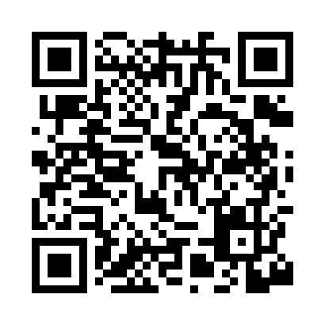

**Prayer times for Abula, Estonia**

**Sun 1 Sep 2024 - Mon 30 Sep 2024**

**High Latitude Method: Angle Based Rule**

**Prayer Calculation Method: Muslim World League**

**Asar Calculation Method: Hanafi**

|  |  |  |  |  |  |  |  |
| --- | --- | --- | --- | --- | --- | --- | --- |
| **Date** | **Day** | **Fajr** | **Sunrise** | **Dhuhr** | **Asr** | **Maghrib** | **Isha** |
| 1 | Sun | 3:48 | 6:31 | 1:31 | 6:11 | 8:30 | 11:00 |
| 2 | Mon | 3:52 | 6:33 | 1:31 | 6:08 | 8:27 | 10:56 |
| 3 | Tue | 3:56 | 6:35 | 1:31 | 6:06 | 8:25 | 10:51 |
| 4 | Wed | 4:00 | 6:38 | 1:30 | 6:04 | 8:22 | 10:47 |
| 5 | Thu | 4:04 | 6:40 | 1:30 | 6:02 | 8:19 | 10:43 |
| 6 | Fri | 4:07 | 6:42 | 1:30 | 6:00 | 8:16 | 10:39 |
| 7 | Sat | 4:11 | 6:44 | 1:29 | 5:57 | 8:13 | 10:35 |
| 8 | Sun | 4:15 | 6:46 | 1:29 | 5:55 | 8:10 | 10:31 |
| 9 | Mon | 4:18 | 6:49 | 1:29 | 5:53 | 8:07 | 10:27 |
| 10 | Tue | 4:21 | 6:51 | 1:28 | 5:51 | 8:04 | 10:23 |
| 11 | Wed | 4:25 | 6:53 | 1:28 | 5:48 | 8:02 | 10:19 |
| 12 | Thu | 4:28 | 6:55 | 1:28 | 5:46 | 7:59 | 10:15 |
| 13 | Fri | 4:31 | 6:57 | 1:27 | 5:44 | 7:56 | 10:11 |
| 14 | Sat | 4:34 | 6:59 | 1:27 | 5:41 | 7:53 | 10:08 |
| 15 | Sun | 4:38 | 7:02 | 1:26 | 5:39 | 7:50 | 10:04 |
| 16 | Mon | 4:41 | 7:04 | 1:26 | 5:36 | 7:47 | 10:00 |
| 17 | Tue | 4:44 | 7:06 | 1:26 | 5:34 | 7:44 | 9:57 |
| 18 | Wed | 4:47 | 7:08 | 1:25 | 5:32 | 7:41 | 9:53 |
| 19 | Thu | 4:50 | 7:10 | 1:25 | 5:29 | 7:39 | 9:50 |
| 20 | Fri | 4:53 | 7:12 | 1:25 | 5:27 | 7:36 | 9:46 |
| 21 | Sat | 4:55 | 7:15 | 1:24 | 5:24 | 7:33 | 9:43 |
| 22 | Sun | 4:58 | 7:17 | 1:24 | 5:22 | 7:30 | 9:39 |
| 23 | Mon | 5:01 | 7:19 | 1:24 | 5:20 | 7:27 | 9:36 |
| 24 | Tue | 5:04 | 7:21 | 1:23 | 5:17 | 7:24 | 9:32 |
| 25 | Wed | 5:06 | 7:23 | 1:23 | 5:15 | 7:21 | 9:29 |
| 26 | Thu | 5:09 | 7:26 | 1:23 | 5:12 | 7:18 | 9:26 |
| 27 | Fri | 5:12 | 7:28 | 1:22 | 5:10 | 7:15 | 9:23 |
| 28 | Sat | 5:14 | 7:30 | 1:22 | 5:07 | 7:13 | 9:19 |
| 29 | Sun | 5:17 | 7:32 | 1:22 | 5:05 | 7:10 | 9:16 |
| 30 | Mon | 5:20 | 7:34 | 1:21 | 5:02 | 7:07 | 9:13 |

**Prayer times provided by https://www.salahtimes.com**