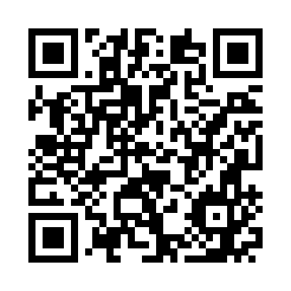
Prayer times for Albosaggia, Italy
Wed 1 May 2024 - Fri 31 May 2024
High Latitude Method: Angle Based Rule
Prayer Calculation Method: Muslim World League
Asar Calculation Method: Hanafi

Date | Day | Fajr | Sunrise | Dhuhr | Asr | Maghrib | Isha
1 | Wed | 4:05 | 6:07 | 1:18 | 6:19 | 8:29 | 10:23
2 | Thu | 4:03 | 6:05 | 1:18 | 6:20 | 8:31 | 10:25
3 | Fri | 4:00 | 6:04 | 1:17 | 6:21 | 8:32 | 10:27
4 | Sat | 3:58 | 6:02 | 1:17 | 6:21 | 8:33 | 10:29
5 | Sun | 3:56 | 6:01 | 1:17 | 6:22 | 8:35 | 10:31
6 | Mon | 3:53 | 5:59 | 1:17 | 6:23 | 8:36 | 10:33
7 | Tue | 3:51 | 5:58 | 1:17 | 6:24 | 8:37 | 10:35
8 | Wed | 3:49 | 5:56 | 1:17 | 6:24 | 8:38 | 10:38
9 | Thu | 3:46 | 5:55 | 1:17 | 6:25 | 8:40 | 10:40
10 | Fri | 3:44 | 5:54 | 1:17 | 6:26 | 8:41 | 10:42
11 | Sat | 3:42 | 5:52 | 1:17 | 6:27 | 8:42 | 10:44
12 | Sun | 3:39 | 5:51 | 1:17 | 6:27 | 8:43 | 10:46
13 | Mon | 3:37 | 5:50 | 1:17 | 6:28 | 8:45 | 10:48
14 | Tue | 3:35 | 5:49 | 1:17 | 6:29 | 8:46 | 10:50
15 | Wed | 3:33 | 5:48 | 1:17 | 6:30 | 8:47 | 10:52
16 | Thu | 3:31 | 5:46 | 1:17 | 6:30 | 8:48 | 10:54
17 | Fri | 3:28 | 5:45 | 1:17 | 6:31 | 8:49 | 10:56
18 | Sat | 3:26 | 5:44 | 1:17 | 6:32 | 8:50 | 10:58
19 | Sun | 3:24 | 5:43 | 1:17 | 6:32 | 8:52 | 11:00
20 | Mon | 3:22 | 5:42 | 1:17 | 6:33 | 8:53 | 11:03
21 | Tue | 3:20 | 5:41 | 1:17 | 6:34 | 8:54 | 11:05
22 | Wed | 3:18 | 5:40 | 1:17 | 6:34 | 8:55 | 11:07
23 | Thu | 3:16 | 5:39 | 1:17 | 6:35 | 8:56 | 11:09
24 | Fri | 3:14 | 5:38 | 1:17 | 6:36 | 8:57 | 11:11
25 | Sat | 3:12 | 5:38 | 1:18 | 6:36 | 8:58 | 11:12
26 | Sun | 3:10 | 5:37 | 1:18 | 6:37 | 8:59 | 11:14
27 | Mon | 3:08 | 5:36 | 1:18 | 6:37 | 9:00 | 11:16
28 | Tue | 3:06 | 5:35 | 1:18 | 6:38 | 9:01 | 11:18
29 | Wed | 3:05 | 5:34 | 1:18 | 6:39 | 9:02 | 11:20
30 | Thu | 3:03 | 5:34 | 1:18 | 6:39 | 9:03 | 11:22
31 | Fri | 3:01 | 5:33 | 1:18 | 6:40 | 9:04 | 11:24
Prayer times provided by https://www.salahtimes.com

