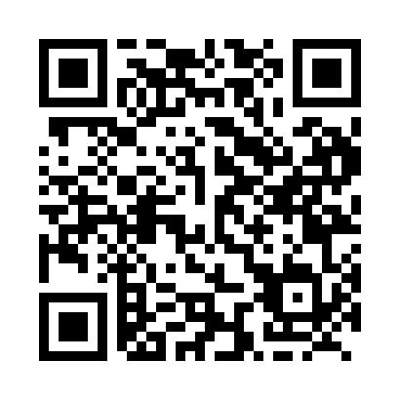
Prayer times for Salmon Point, Ontario, Canada
Mon 1 Jul 2024 - Wed 31 Jul 2024
High Latitude Method: Angle Based Rule
Prayer Calculation Method: Islamic Society of North America
Asar Calculation Method: Hanafi

Date | Day | Fajr | Sunrise | Dhuhr | Asr | Maghrib | Isha
1 | Mon | 3:40 | 5:31 | 1:13 | 6:33 | 8:55 | 10:45
2 | Tue | 3:41 | 5:31 | 1:13 | 6:33 | 8:55 | 10:44
3 | Wed | 3:42 | 5:32 | 1:13 | 6:33 | 8:54 | 10:44
4 | Thu | 3:43 | 5:32 | 1:13 | 6:32 | 8:54 | 10:43
5 | Fri | 3:44 | 5:33 | 1:14 | 6:32 | 8:54 | 10:43
6 | Sat | 3:45 | 5:34 | 1:14 | 6:32 | 8:53 | 10:42
7 | Sun | 3:46 | 5:34 | 1:14 | 6:32 | 8:53 | 10:41
8 | Mon | 3:47 | 5:35 | 1:14 | 6:32 | 8:53 | 10:40
9 | Tue | 3:48 | 5:36 | 1:14 | 6:32 | 8:52 | 10:39
10 | Wed | 3:50 | 5:37 | 1:14 | 6:32 | 8:52 | 10:38
11 | Thu | 3:51 | 5:38 | 1:14 | 6:31 | 8:51 | 10:38
12 | Fri | 3:52 | 5:38 | 1:15 | 6:31 | 8:50 | 10:36
13 | Sat | 3:53 | 5:39 | 1:15 | 6:31 | 8:50 | 10:35
14 | Sun | 3:55 | 5:40 | 1:15 | 6:31 | 8:49 | 10:34
15 | Mon | 3:56 | 5:41 | 1:15 | 6:30 | 8:49 | 10:33
16 | Tue | 3:57 | 5:42 | 1:15 | 6:30 | 8:48 | 10:32
17 | Wed | 3:59 | 5:43 | 1:15 | 6:29 | 8:47 | 10:31
18 | Thu | 4:00 | 5:44 | 1:15 | 6:29 | 8:46 | 10:29
19 | Fri | 4:02 | 5:45 | 1:15 | 6:29 | 8:45 | 10:28
20 | Sat | 4:03 | 5:46 | 1:15 | 6:28 | 8:45 | 10:27
21 | Sun | 4:05 | 5:47 | 1:15 | 6:28 | 8:44 | 10:25
22 | Mon | 4:06 | 5:48 | 1:15 | 6:27 | 8:43 | 10:24
23 | Tue | 4:08 | 5:49 | 1:15 | 6:27 | 8:42 | 10:22
24 | Wed | 4:09 | 5:50 | 1:15 | 6:26 | 8:41 | 10:21
25 | Thu | 4:11 | 5:51 | 1:15 | 6:26 | 8:40 | 10:19
26 | Fri | 4:12 | 5:52 | 1:15 | 6:25 | 8:39 | 10:18
27 | Sat | 4:14 | 5:53 | 1:15 | 6:24 | 8:38 | 10:16
28 | Sun | 4:15 | 5:54 | 1:15 | 6:24 | 8:36 | 10:14
29 | Mon | 4:17 | 5:55 | 1:15 | 6:23 | 8:35 | 10:13
30 | Tue | 4:19 | 5:56 | 1:15 | 6:22 | 8:34 | 10:11
31 | Wed | 4:20 | 5:57 | 1:15 | 6:22 | 8:33 | 10:09
Prayer times provided by https://www.salahtimes.com

