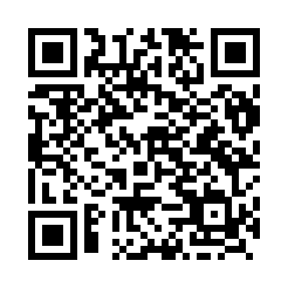

**Prayer times for Abulas, Latvia**

**Sun 1 Sep 2024 - Mon 30 Sep 2024**

**High Latitude Method: Angle Based Rule**

**Prayer Calculation Method: Muslim World League**

**Asar Calculation Method: Hanafi**

|  |  |  |  |  |  |  |  |
| --- | --- | --- | --- | --- | --- | --- | --- |
| **Date** | **Day** | **Fajr** | **Sunrise** | **Dhuhr** | **Asr** | **Maghrib** | **Isha** |
| 1 | Sun | 4:02 | 6:34 | 1:30 | 6:10 | 8:26 | 10:45 |
| 2 | Mon | 4:06 | 6:36 | 1:30 | 6:08 | 8:23 | 10:41 |
| 3 | Tue | 4:09 | 6:38 | 1:30 | 6:06 | 8:20 | 10:37 |
| 4 | Wed | 4:13 | 6:40 | 1:29 | 6:04 | 8:18 | 10:34 |
| 5 | Thu | 4:16 | 6:42 | 1:29 | 6:01 | 8:15 | 10:30 |
| 6 | Fri | 4:19 | 6:44 | 1:29 | 5:59 | 8:12 | 10:26 |
| 7 | Sat | 4:22 | 6:46 | 1:28 | 5:57 | 8:10 | 10:23 |
| 8 | Sun | 4:26 | 6:48 | 1:28 | 5:55 | 8:07 | 10:19 |
| 9 | Mon | 4:29 | 6:50 | 1:28 | 5:53 | 8:04 | 10:15 |
| 10 | Tue | 4:32 | 6:52 | 1:27 | 5:51 | 8:01 | 10:12 |
| 11 | Wed | 4:35 | 6:54 | 1:27 | 5:48 | 7:59 | 10:08 |
| 12 | Thu | 4:38 | 6:56 | 1:27 | 5:46 | 7:56 | 10:05 |
| 13 | Fri | 4:40 | 6:58 | 1:26 | 5:44 | 7:53 | 10:01 |
| 14 | Sat | 4:43 | 7:00 | 1:26 | 5:42 | 7:51 | 9:58 |
| 15 | Sun | 4:46 | 7:02 | 1:26 | 5:40 | 7:48 | 9:54 |
| 16 | Mon | 4:49 | 7:04 | 1:25 | 5:37 | 7:45 | 9:51 |
| 17 | Tue | 4:52 | 7:06 | 1:25 | 5:35 | 7:42 | 9:48 |
| 18 | Wed | 4:54 | 7:08 | 1:24 | 5:33 | 7:40 | 9:44 |
| 19 | Thu | 4:57 | 7:10 | 1:24 | 5:31 | 7:37 | 9:41 |
| 20 | Fri | 4:59 | 7:12 | 1:24 | 5:28 | 7:34 | 9:38 |
| 21 | Sat | 5:02 | 7:14 | 1:23 | 5:26 | 7:31 | 9:35 |
| 22 | Sun | 5:05 | 7:16 | 1:23 | 5:24 | 7:29 | 9:32 |
| 23 | Mon | 5:07 | 7:18 | 1:23 | 5:21 | 7:26 | 9:28 |
| 24 | Tue | 5:10 | 7:20 | 1:22 | 5:19 | 7:23 | 9:25 |
| 25 | Wed | 5:12 | 7:22 | 1:22 | 5:17 | 7:20 | 9:22 |
| 26 | Thu | 5:15 | 7:24 | 1:22 | 5:14 | 7:18 | 9:19 |
| 27 | Fri | 5:17 | 7:26 | 1:21 | 5:12 | 7:15 | 9:16 |
| 28 | Sat | 5:19 | 7:28 | 1:21 | 5:10 | 7:12 | 9:13 |
| 29 | Sun | 5:22 | 7:30 | 1:21 | 5:07 | 7:10 | 9:10 |
| 30 | Mon | 5:24 | 7:33 | 1:20 | 5:05 | 7:07 | 9:07 |

**Prayer times provided by https://www.salahtimes.com**