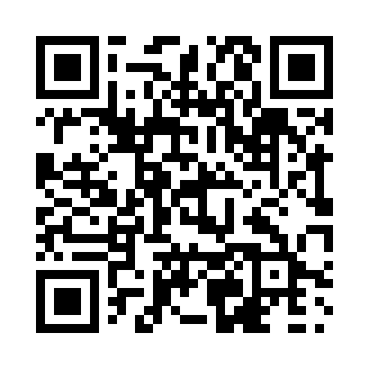
Prayer times for Belwood, Ontario, Canada
Mon 1 Apr 2024 - Tue 30 Apr 2024
High Latitude Method: Angle Based Rule
Prayer Calculation Method: Islamic Society of North America
Asar Calculation Method: Hanafi

Date | Day | Fajr | Sunrise | Dhuhr | Asr | Maghrib | Isha
1 | Mon | 5:40 | 7:02 | 1:25 | 5:55 | 7:49 | 9:10
2 | Tue | 5:38 | 7:00 | 1:25 | 5:55 | 7:50 | 9:12
3 | Wed | 5:36 | 6:58 | 1:24 | 5:56 | 7:51 | 9:13
4 | Thu | 5:34 | 6:56 | 1:24 | 5:57 | 7:52 | 9:15
5 | Fri | 5:32 | 6:55 | 1:24 | 5:58 | 7:54 | 9:16
6 | Sat | 5:30 | 6:53 | 1:24 | 5:59 | 7:55 | 9:18
7 | Sun | 5:28 | 6:51 | 1:23 | 6:00 | 7:56 | 9:19
8 | Mon | 5:26 | 6:49 | 1:23 | 6:00 | 7:57 | 9:20
9 | Tue | 5:24 | 6:48 | 1:23 | 6:01 | 7:58 | 9:22
10 | Wed | 5:22 | 6:46 | 1:22 | 6:02 | 8:00 | 9:23
11 | Thu | 5:20 | 6:44 | 1:22 | 6:03 | 8:01 | 9:25
12 | Fri | 5:18 | 6:42 | 1:22 | 6:04 | 8:02 | 9:26
13 | Sat | 5:16 | 6:41 | 1:22 | 6:04 | 8:03 | 9:28
14 | Sun | 5:14 | 6:39 | 1:21 | 6:05 | 8:04 | 9:30
15 | Mon | 5:12 | 6:37 | 1:21 | 6:06 | 8:06 | 9:31
16 | Tue | 5:10 | 6:36 | 1:21 | 6:07 | 8:07 | 9:33
17 | Wed | 5:08 | 6:34 | 1:21 | 6:07 | 8:08 | 9:34
18 | Thu | 5:06 | 6:32 | 1:20 | 6:08 | 8:09 | 9:36
19 | Fri | 5:04 | 6:31 | 1:20 | 6:09 | 8:10 | 9:37
20 | Sat | 5:02 | 6:29 | 1:20 | 6:10 | 8:12 | 9:39
21 | Sun | 5:00 | 6:28 | 1:20 | 6:10 | 8:13 | 9:40
22 | Mon | 4:58 | 6:26 | 1:20 | 6:11 | 8:14 | 9:42
23 | Tue | 4:56 | 6:24 | 1:19 | 6:12 | 8:15 | 9:44
24 | Wed | 4:54 | 6:23 | 1:19 | 6:13 | 8:16 | 9:45
25 | Thu | 4:52 | 6:21 | 1:19 | 6:13 | 8:18 | 9:47
26 | Fri | 4:51 | 6:20 | 1:19 | 6:14 | 8:19 | 9:48
27 | Sat | 4:49 | 6:18 | 1:19 | 6:15 | 8:20 | 9:50
28 | Sun | 4:47 | 6:17 | 1:19 | 6:15 | 8:21 | 9:52
29 | Mon | 4:45 | 6:15 | 1:19 | 6:16 | 8:22 | 9:53
30 | Tue | 4:43 | 6:14 | 1:18 | 6:17 | 8:24 | 9:55
Prayer times provided by https://www.salahtimes.com

