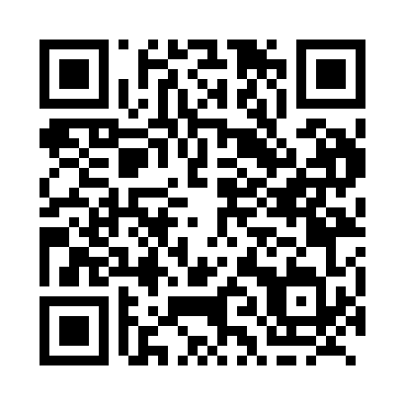
Prayer times for Cheecham, Alberta, Canada
Mon 1 Jul 2024 - Wed 31 Jul 2024
High Latitude Method: Angle Based Rule
Prayer Calculation Method: Islamic Society of North America
Asar Calculation Method: Hanafi

Date | Day | Fajr | Sunrise | Dhuhr | Asr | Maghrib | Isha
1 | Mon | 3:04 | 4:40 | 1:28 | 7:15 | 10:14 | 11:51
2 | Tue | 3:04 | 4:41 | 1:28 | 7:15 | 10:14 | 11:51
3 | Wed | 3:05 | 4:42 | 1:28 | 7:15 | 10:13 | 11:50
4 | Thu | 3:06 | 4:43 | 1:28 | 7:15 | 10:12 | 11:50
5 | Fri | 3:06 | 4:44 | 1:28 | 7:14 | 10:12 | 11:50
6 | Sat | 3:07 | 4:46 | 1:28 | 7:14 | 10:11 | 11:49
7 | Sun | 3:08 | 4:47 | 1:29 | 7:14 | 10:10 | 11:49
8 | Mon | 3:08 | 4:48 | 1:29 | 7:13 | 10:09 | 11:49
9 | Tue | 3:09 | 4:49 | 1:29 | 7:13 | 10:08 | 11:48
10 | Wed | 3:10 | 4:51 | 1:29 | 7:13 | 10:07 | 11:48
11 | Thu | 3:10 | 4:52 | 1:29 | 7:12 | 10:06 | 11:47
12 | Fri | 3:11 | 4:53 | 1:29 | 7:12 | 10:05 | 11:47
13 | Sat | 3:12 | 4:55 | 1:29 | 7:11 | 10:03 | 11:46
14 | Sun | 3:13 | 4:56 | 1:29 | 7:10 | 10:02 | 11:46
15 | Mon | 3:14 | 4:58 | 1:30 | 7:10 | 10:01 | 11:45
16 | Tue | 3:14 | 4:59 | 1:30 | 7:09 | 9:59 | 11:44
17 | Wed | 3:15 | 5:01 | 1:30 | 7:08 | 9:58 | 11:44
18 | Thu | 3:16 | 5:03 | 1:30 | 7:08 | 9:56 | 11:43
19 | Fri | 3:17 | 5:04 | 1:30 | 7:07 | 9:55 | 11:42
20 | Sat | 3:18 | 5:06 | 1:30 | 7:06 | 9:53 | 11:41
21 | Sun | 3:19 | 5:08 | 1:30 | 7:05 | 9:52 | 11:41
22 | Mon | 3:19 | 5:09 | 1:30 | 7:04 | 9:50 | 11:40
23 | Tue | 3:20 | 5:11 | 1:30 | 7:03 | 9:48 | 11:39
24 | Wed | 3:21 | 5:13 | 1:30 | 7:02 | 9:46 | 11:38
25 | Thu | 3:22 | 5:15 | 1:30 | 7:01 | 9:45 | 11:37
26 | Fri | 3:23 | 5:16 | 1:30 | 7:00 | 9:43 | 11:36
27 | Sat | 3:24 | 5:18 | 1:30 | 6:59 | 9:41 | 11:35
28 | Sun | 3:25 | 5:20 | 1:30 | 6:58 | 9:39 | 11:34
29 | Mon | 3:26 | 5:22 | 1:30 | 6:57 | 9:37 | 11:33
30 | Tue | 3:27 | 5:24 | 1:30 | 6:56 | 9:35 | 11:32
31 | Wed | 3:28 | 5:26 | 1:30 | 6:55 | 9:33 | 11:31
Prayer times provided by https://www.salahtimes.com

