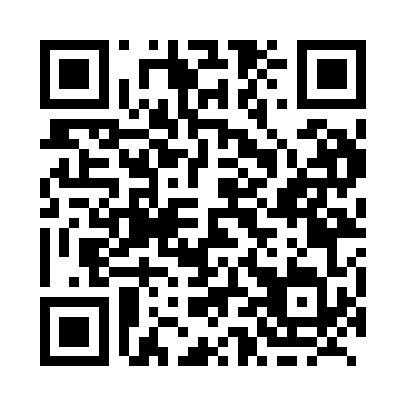

**Prayer times for Qutialuk, Quebec, Canada**

**Sun 1 Sep 2024 - Mon 30 Sep 2024**

**High Latitude Method: Angle Based Rule**

**Prayer Calculation Method: Islamic Society of North America**

**Asar Calculation Method: Hanafi**

|  |  |  |  |  |  |  |  |
| --- | --- | --- | --- | --- | --- | --- | --- |
| **Date** | **Day** | **Fajr** | **Sunrise** | **Dhuhr** | **Asr** | **Maghrib** | **Isha** |
| 1 | Sun | 3:14 | 5:40 | 12:48 | 5:26 | 7:54 | 10:20 |
| 2 | Mon | 3:16 | 5:43 | 12:47 | 5:24 | 7:51 | 10:16 |
| 3 | Tue | 3:20 | 5:45 | 12:47 | 5:21 | 7:48 | 10:11 |
| 4 | Wed | 3:25 | 5:48 | 12:47 | 5:19 | 7:44 | 10:07 |
| 5 | Thu | 3:29 | 5:50 | 12:46 | 5:16 | 7:41 | 10:02 |
| 6 | Fri | 3:33 | 5:53 | 12:46 | 5:14 | 7:38 | 9:57 |
| 7 | Sat | 3:37 | 5:55 | 12:46 | 5:11 | 7:35 | 9:53 |
| 8 | Sun | 3:41 | 5:58 | 12:45 | 5:09 | 7:31 | 9:48 |
| 9 | Mon | 3:44 | 6:00 | 12:45 | 5:06 | 7:28 | 9:44 |
| 10 | Tue | 3:48 | 6:03 | 12:45 | 5:04 | 7:25 | 9:39 |
| 11 | Wed | 3:52 | 6:06 | 12:44 | 5:01 | 7:22 | 9:35 |
| 12 | Thu | 3:55 | 6:08 | 12:44 | 4:59 | 7:18 | 9:31 |
| 13 | Fri | 3:59 | 6:11 | 12:44 | 4:56 | 7:15 | 9:26 |
| 14 | Sat | 4:02 | 6:13 | 12:43 | 4:54 | 7:12 | 9:22 |
| 15 | Sun | 4:06 | 6:16 | 12:43 | 4:51 | 7:09 | 9:18 |
| 16 | Mon | 4:09 | 6:18 | 12:43 | 4:48 | 7:06 | 9:14 |
| 17 | Tue | 4:12 | 6:21 | 12:42 | 4:46 | 7:02 | 9:10 |
| 18 | Wed | 4:16 | 6:23 | 12:42 | 4:43 | 6:59 | 9:06 |
| 19 | Thu | 4:19 | 6:26 | 12:41 | 4:40 | 6:56 | 9:02 |
| 20 | Fri | 4:22 | 6:28 | 12:41 | 4:38 | 6:53 | 8:58 |
| 21 | Sat | 4:25 | 6:31 | 12:41 | 4:35 | 6:49 | 8:55 |
| 22 | Sun | 4:28 | 6:33 | 12:40 | 4:32 | 6:46 | 8:51 |
| 23 | Mon | 4:31 | 6:36 | 12:40 | 4:30 | 6:43 | 8:47 |
| 24 | Tue | 4:34 | 6:38 | 12:40 | 4:27 | 6:40 | 8:43 |
| 25 | Wed | 4:37 | 6:41 | 12:39 | 4:24 | 6:36 | 8:40 |
| 26 | Thu | 4:40 | 6:43 | 12:39 | 4:21 | 6:33 | 8:36 |
| 27 | Fri | 4:43 | 6:46 | 12:39 | 4:19 | 6:30 | 8:32 |
| 28 | Sat | 4:46 | 6:49 | 12:38 | 4:16 | 6:27 | 8:29 |
| 29 | Sun | 4:49 | 6:51 | 12:38 | 4:13 | 6:24 | 8:25 |
| 30 | Mon | 4:52 | 6:54 | 12:38 | 4:10 | 6:20 | 8:22 |

**Prayer times provided by https://www.salahtimes.com**