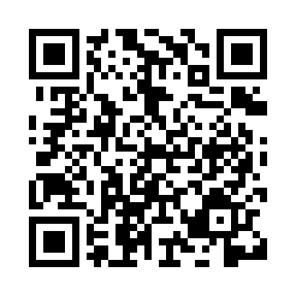
Prayer times for Hungnam, North Korea
Wed 1 May 2024 - Fri 31 May 2024
High Latitude Method: None
Prayer Calculation Method: Muslim World League
Asar Calculation Method: Shafi

Date | Day | Fajr | Sunrise | Dhuhr | Asr | Maghrib | Isha
1 | Wed | 3:47 | 5:30 | 12:27 | 4:17 | 7:24 | 9:01
2 | Thu | 3:45 | 5:29 | 12:27 | 4:17 | 7:25 | 9:02
3 | Fri | 3:44 | 5:28 | 12:26 | 4:17 | 7:26 | 9:04
4 | Sat | 3:42 | 5:26 | 12:26 | 4:18 | 7:27 | 9:05
5 | Sun | 3:40 | 5:25 | 12:26 | 4:18 | 7:28 | 9:06
6 | Mon | 3:39 | 5:24 | 12:26 | 4:18 | 7:29 | 9:08
7 | Tue | 3:37 | 5:23 | 12:26 | 4:18 | 7:30 | 9:09
8 | Wed | 3:35 | 5:22 | 12:26 | 4:19 | 7:31 | 9:11
9 | Thu | 3:34 | 5:21 | 12:26 | 4:19 | 7:32 | 9:12
10 | Fri | 3:32 | 5:20 | 12:26 | 4:19 | 7:33 | 9:14
11 | Sat | 3:31 | 5:19 | 12:26 | 4:19 | 7:34 | 9:15
12 | Sun | 3:29 | 5:18 | 12:26 | 4:20 | 7:35 | 9:16
13 | Mon | 3:28 | 5:17 | 12:26 | 4:20 | 7:36 | 9:18
14 | Tue | 3:26 | 5:16 | 12:26 | 4:20 | 7:37 | 9:19
15 | Wed | 3:25 | 5:15 | 12:26 | 4:20 | 7:38 | 9:21
16 | Thu | 3:23 | 5:14 | 12:26 | 4:21 | 7:39 | 9:22
17 | Fri | 3:22 | 5:13 | 12:26 | 4:21 | 7:39 | 9:23
18 | Sat | 3:21 | 5:12 | 12:26 | 4:21 | 7:40 | 9:25
19 | Sun | 3:19 | 5:11 | 12:26 | 4:21 | 7:41 | 9:26
20 | Mon | 3:18 | 5:11 | 12:26 | 4:22 | 7:42 | 9:27
21 | Tue | 3:17 | 5:10 | 12:26 | 4:22 | 7:43 | 9:29
22 | Wed | 3:15 | 5:09 | 12:26 | 4:22 | 7:44 | 9:30
23 | Thu | 3:14 | 5:08 | 12:26 | 4:22 | 7:45 | 9:31
24 | Fri | 3:13 | 5:08 | 12:26 | 4:23 | 7:46 | 9:33
25 | Sat | 3:12 | 5:07 | 12:27 | 4:23 | 7:47 | 9:34
26 | Sun | 3:11 | 5:06 | 12:27 | 4:23 | 7:47 | 9:35
27 | Mon | 3:10 | 5:06 | 12:27 | 4:24 | 7:48 | 9:36
28 | Tue | 3:09 | 5:05 | 12:27 | 4:24 | 7:49 | 9:38
29 | Wed | 3:08 | 5:05 | 12:27 | 4:24 | 7:50 | 9:39
30 | Thu | 3:07 | 5:04 | 12:27 | 4:24 | 7:50 | 9:40
31 | Fri | 3:06 | 5:04 | 12:27 | 4:25 | 7:51 | 9:41
Prayer times provided by https://www.salahtimes.com

