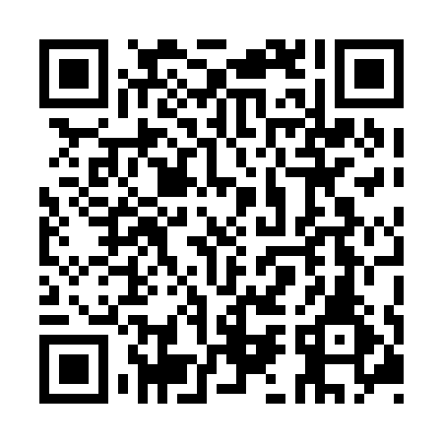
Prayer times for Cross Point Station, Quebec, Canada
Wed 1 May 2024 - Fri 31 May 2024
High Latitude Method: Angle Based Rule
Prayer Calculation Method: Islamic Society of North America
Asar Calculation Method: Hanafi

Date | Day | Fajr | Sunrise | Dhuhr | Asr | Maghrib | Isha
1 | Wed | 3:25 | 5:08 | 12:24 | 5:27 | 7:41 | 9:24
2 | Thu | 3:22 | 5:06 | 12:24 | 5:28 | 7:42 | 9:26
3 | Fri | 3:20 | 5:04 | 12:24 | 5:29 | 7:44 | 9:29
4 | Sat | 3:18 | 5:03 | 12:24 | 5:30 | 7:45 | 9:31
5 | Sun | 3:15 | 5:01 | 12:23 | 5:31 | 7:46 | 9:33
6 | Mon | 3:13 | 5:00 | 12:23 | 5:32 | 7:48 | 9:35
7 | Tue | 3:11 | 4:58 | 12:23 | 5:33 | 7:49 | 9:37
8 | Wed | 3:09 | 4:57 | 12:23 | 5:33 | 7:51 | 9:39
9 | Thu | 3:06 | 4:55 | 12:23 | 5:34 | 7:52 | 9:41
10 | Fri | 3:04 | 4:54 | 12:23 | 5:35 | 7:53 | 9:43
11 | Sat | 3:02 | 4:52 | 12:23 | 5:36 | 7:55 | 9:46
12 | Sun | 3:00 | 4:51 | 12:23 | 5:37 | 7:56 | 9:48
13 | Mon | 2:58 | 4:50 | 12:23 | 5:37 | 7:57 | 9:50
14 | Tue | 2:55 | 4:48 | 12:23 | 5:38 | 7:58 | 9:52
15 | Wed | 2:53 | 4:47 | 12:23 | 5:39 | 8:00 | 9:54
16 | Thu | 2:51 | 4:46 | 12:23 | 5:40 | 8:01 | 9:56
17 | Fri | 2:49 | 4:45 | 12:23 | 5:40 | 8:02 | 9:58
18 | Sat | 2:47 | 4:44 | 12:23 | 5:41 | 8:04 | 10:00
19 | Sun | 2:45 | 4:42 | 12:23 | 5:42 | 8:05 | 10:03
20 | Mon | 2:43 | 4:41 | 12:23 | 5:43 | 8:06 | 10:05
21 | Tue | 2:41 | 4:40 | 12:23 | 5:43 | 8:07 | 10:07
22 | Wed | 2:39 | 4:39 | 12:24 | 5:44 | 8:08 | 10:09
23 | Thu | 2:38 | 4:38 | 12:24 | 5:45 | 8:10 | 10:11
24 | Fri | 2:36 | 4:37 | 12:24 | 5:45 | 8:11 | 10:13
25 | Sat | 2:34 | 4:36 | 12:24 | 5:46 | 8:12 | 10:15
26 | Sun | 2:32 | 4:35 | 12:24 | 5:47 | 8:13 | 10:17
27 | Mon | 2:30 | 4:35 | 12:24 | 5:47 | 8:14 | 10:19
28 | Tue | 2:29 | 4:34 | 12:24 | 5:48 | 8:15 | 10:20
29 | Wed | 2:29 | 4:33 | 12:24 | 5:49 | 8:16 | 10:20
30 | Thu | 2:28 | 4:32 | 12:24 | 5:49 | 8:17 | 10:21
31 | Fri | 2:28 | 4:32 | 12:25 | 5:50 | 8:18 | 10:21
Prayer times provided by https://www.salahtimes.com

