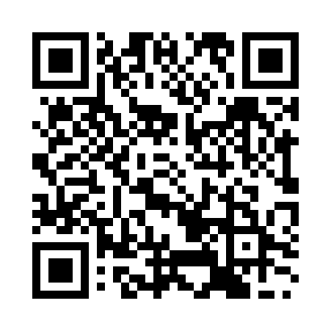
Prayer times for Nishinoshima, Japan
Wed 1 May 2024 - Fri 31 May 2024
High Latitude Method: None
Prayer Calculation Method: Muslim World League
Asar Calculation Method: Shafi

Date | Day | Fajr | Sunrise | Dhuhr | Asr | Maghrib | Isha
1 | Wed | 3:40 | 5:15 | 12:05 | 3:51 | 6:55 | 8:25
2 | Thu | 3:38 | 5:14 | 12:05 | 3:51 | 6:56 | 8:26
3 | Fri | 3:37 | 5:13 | 12:05 | 3:51 | 6:57 | 8:28
4 | Sat | 3:35 | 5:12 | 12:05 | 3:51 | 6:58 | 8:29
5 | Sun | 3:34 | 5:11 | 12:05 | 3:51 | 6:59 | 8:30
6 | Mon | 3:33 | 5:10 | 12:05 | 3:51 | 7:00 | 8:31
7 | Tue | 3:31 | 5:09 | 12:05 | 3:51 | 7:00 | 8:32
8 | Wed | 3:30 | 5:08 | 12:05 | 3:51 | 7:01 | 8:34
9 | Thu | 3:29 | 5:07 | 12:04 | 3:52 | 7:02 | 8:35
10 | Fri | 3:27 | 5:06 | 12:04 | 3:52 | 7:03 | 8:36
11 | Sat | 3:26 | 5:05 | 12:04 | 3:52 | 7:04 | 8:37
12 | Sun | 3:25 | 5:05 | 12:04 | 3:52 | 7:05 | 8:38
13 | Mon | 3:24 | 5:04 | 12:04 | 3:52 | 7:05 | 8:39
14 | Tue | 3:22 | 5:03 | 12:04 | 3:52 | 7:06 | 8:41
15 | Wed | 3:21 | 5:02 | 12:04 | 3:52 | 7:07 | 8:42
16 | Thu | 3:20 | 5:01 | 12:04 | 3:53 | 7:08 | 8:43
17 | Fri | 3:19 | 5:01 | 12:04 | 3:53 | 7:09 | 8:44
18 | Sat | 3:18 | 5:00 | 12:04 | 3:53 | 7:09 | 8:45
19 | Sun | 3:17 | 4:59 | 12:05 | 3:53 | 7:10 | 8:46
20 | Mon | 3:16 | 4:58 | 12:05 | 3:53 | 7:11 | 8:47
21 | Tue | 3:15 | 4:58 | 12:05 | 3:53 | 7:12 | 8:48
22 | Wed | 3:14 | 4:57 | 12:05 | 3:54 | 7:13 | 8:50
23 | Thu | 3:13 | 4:57 | 12:05 | 3:54 | 7:13 | 8:51
24 | Fri | 3:12 | 4:56 | 12:05 | 3:54 | 7:14 | 8:52
25 | Sat | 3:11 | 4:55 | 12:05 | 3:54 | 7:15 | 8:53
26 | Sun | 3:10 | 4:55 | 12:05 | 3:54 | 7:16 | 8:54
27 | Mon | 3:09 | 4:54 | 12:05 | 3:55 | 7:16 | 8:55
28 | Tue | 3:08 | 4:54 | 12:05 | 3:55 | 7:17 | 8:56
29 | Wed | 3:08 | 4:54 | 12:05 | 3:55 | 7:18 | 8:57
30 | Thu | 3:07 | 4:53 | 12:06 | 3:55 | 7:18 | 8:58
31 | Fri | 3:06 | 4:53 | 12:06 | 3:55 | 7:19 | 8:59
Prayer times provided by https://www.salahtimes.com

