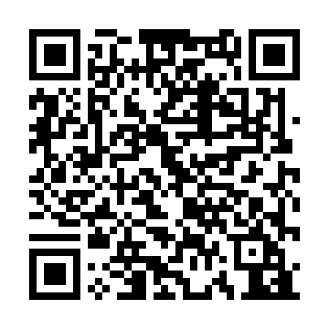
Prayer times for Loison-sous-Lens, France
Wed 1 May 2024 - Fri 31 May 2024
High Latitude Method: Angle Based Rule
Prayer Calculation Method: Islamic Organisations Union of France
Asar Calculation Method: Shafi

Date | Day | Fajr | Sunrise | Dhuhr | Asr | Maghrib | Isha
1 | Wed | 4:58 | 6:23 | 1:46 | 5:48 | 9:09 | 10:34
2 | Thu | 4:56 | 6:21 | 1:46 | 5:48 | 9:11 | 10:37
3 | Fri | 4:53 | 6:19 | 1:45 | 5:49 | 9:12 | 10:39
4 | Sat | 4:51 | 6:18 | 1:45 | 5:49 | 9:14 | 10:41
5 | Sun | 4:49 | 6:16 | 1:45 | 5:50 | 9:15 | 10:43
6 | Mon | 4:46 | 6:14 | 1:45 | 5:51 | 9:17 | 10:45
7 | Tue | 4:44 | 6:13 | 1:45 | 5:51 | 9:18 | 10:47
8 | Wed | 4:42 | 6:11 | 1:45 | 5:52 | 9:20 | 10:49
9 | Thu | 4:40 | 6:09 | 1:45 | 5:52 | 9:21 | 10:52
10 | Fri | 4:37 | 6:08 | 1:45 | 5:53 | 9:23 | 10:54
11 | Sat | 4:35 | 6:06 | 1:45 | 5:54 | 9:24 | 10:56
12 | Sun | 4:33 | 6:05 | 1:45 | 5:54 | 9:26 | 10:58
13 | Mon | 4:31 | 6:03 | 1:45 | 5:55 | 9:27 | 11:00
14 | Tue | 4:29 | 6:02 | 1:45 | 5:55 | 9:29 | 11:02
15 | Wed | 4:27 | 6:00 | 1:45 | 5:56 | 9:30 | 11:04
16 | Thu | 4:24 | 5:59 | 1:45 | 5:56 | 9:32 | 11:07
17 | Fri | 4:22 | 5:58 | 1:45 | 5:57 | 9:33 | 11:09
18 | Sat | 4:20 | 5:56 | 1:45 | 5:57 | 9:34 | 11:11
19 | Sun | 4:18 | 5:55 | 1:45 | 5:58 | 9:36 | 11:13
20 | Mon | 4:16 | 5:54 | 1:45 | 5:59 | 9:37 | 11:15
21 | Tue | 4:14 | 5:53 | 1:45 | 5:59 | 9:38 | 11:17
22 | Wed | 4:13 | 5:51 | 1:45 | 6:00 | 9:40 | 11:18
23 | Thu | 4:12 | 5:50 | 1:45 | 6:00 | 9:41 | 11:19
24 | Fri | 4:12 | 5:49 | 1:45 | 6:01 | 9:42 | 11:20
25 | Sat | 4:11 | 5:48 | 1:46 | 6:01 | 9:44 | 11:20
26 | Sun | 4:11 | 5:47 | 1:46 | 6:02 | 9:45 | 11:21
27 | Mon | 4:10 | 5:46 | 1:46 | 6:02 | 9:46 | 11:22
28 | Tue | 4:10 | 5:45 | 1:46 | 6:03 | 9:47 | 11:23
29 | Wed | 4:09 | 5:44 | 1:46 | 6:03 | 9:48 | 11:23
30 | Thu | 4:09 | 5:44 | 1:46 | 6:03 | 9:49 | 11:24
31 | Fri | 4:08 | 5:43 | 1:46 | 6:04 | 9:50 | 11:25
Prayer times provided by https://www.salahtimes.com

