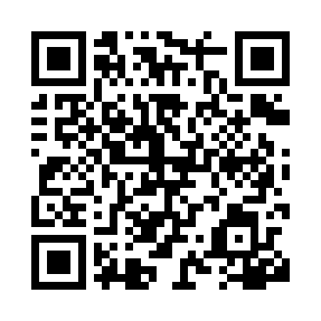

**Prayer times for Nizhneudinsk, Russia**

**Wed 1 Jan 2025 - Fri 31 Jan 2025**

**High Latitude Method: Angle Based Rule**

**Prayer Calculation Method: Spiritual Administration of Muslims of Russia**

**Asar Calculation Method: Shafi**

|  |  |  |  |  |  |  |  |
| --- | --- | --- | --- | --- | --- | --- | --- |
| **Date** | **Day** | **Fajr** | **Sunrise** | **Dhuhr** | **Asr** | **Maghrib** | **Isha** |
| 1 | Wed | 7:46 | 9:48 | 1:27 | 2:52 | 5:07 | 7:01 |
| 2 | Thu | 7:46 | 9:48 | 1:28 | 2:53 | 5:08 | 7:02 |
| 3 | Fri | 7:46 | 9:48 | 1:28 | 2:54 | 5:10 | 7:03 |
| 4 | Sat | 7:46 | 9:47 | 1:29 | 2:56 | 5:11 | 7:05 |
| 5 | Sun | 7:46 | 9:47 | 1:29 | 2:57 | 5:12 | 7:06 |
| 6 | Mon | 7:46 | 9:46 | 1:30 | 2:58 | 5:14 | 7:07 |
| 7 | Tue | 7:45 | 9:46 | 1:30 | 2:59 | 5:15 | 7:08 |
| 8 | Wed | 7:45 | 9:45 | 1:31 | 3:00 | 5:17 | 7:09 |
| 9 | Thu | 7:45 | 9:45 | 1:31 | 3:01 | 5:18 | 7:10 |
| 10 | Fri | 7:44 | 9:44 | 1:31 | 3:03 | 5:20 | 7:12 |
| 11 | Sat | 7:44 | 9:43 | 1:32 | 3:04 | 5:21 | 7:13 |
| 12 | Sun | 7:43 | 9:42 | 1:32 | 3:05 | 5:23 | 7:14 |
| 13 | Mon | 7:43 | 9:41 | 1:33 | 3:07 | 5:25 | 7:16 |
| 14 | Tue | 7:42 | 9:40 | 1:33 | 3:08 | 5:26 | 7:17 |
| 15 | Wed | 7:41 | 9:39 | 1:33 | 3:09 | 5:28 | 7:19 |
| 16 | Thu | 7:41 | 9:38 | 1:34 | 3:11 | 5:30 | 7:20 |
| 17 | Fri | 7:40 | 9:37 | 1:34 | 3:12 | 5:32 | 7:22 |
| 18 | Sat | 7:39 | 9:36 | 1:34 | 3:14 | 5:34 | 7:23 |
| 19 | Sun | 7:38 | 9:35 | 1:35 | 3:15 | 5:35 | 7:25 |
| 20 | Mon | 7:37 | 9:33 | 1:35 | 3:17 | 5:37 | 7:26 |
| 21 | Tue | 7:36 | 9:32 | 1:35 | 3:18 | 5:39 | 7:28 |
| 22 | Wed | 7:35 | 9:31 | 1:35 | 3:20 | 5:41 | 7:29 |
| 23 | Thu | 7:34 | 9:29 | 1:36 | 3:21 | 5:43 | 7:31 |
| 24 | Fri | 7:33 | 9:28 | 1:36 | 3:23 | 5:45 | 7:32 |
| 25 | Sat | 7:32 | 9:26 | 1:36 | 3:24 | 5:47 | 7:34 |
| 26 | Sun | 7:31 | 9:25 | 1:36 | 3:26 | 5:49 | 7:36 |
| 27 | Mon | 7:30 | 9:23 | 1:37 | 3:28 | 5:51 | 7:37 |
| 28 | Tue | 7:28 | 9:21 | 1:37 | 3:29 | 5:53 | 7:39 |
| 29 | Wed | 7:27 | 9:20 | 1:37 | 3:31 | 5:55 | 7:41 |
| 30 | Thu | 7:26 | 9:18 | 1:37 | 3:32 | 5:57 | 7:42 |
| 31 | Fri | 7:24 | 9:16 | 1:37 | 3:34 | 5:59 | 7:44 |

**Prayer times provided by https://www.salahtimes.com**