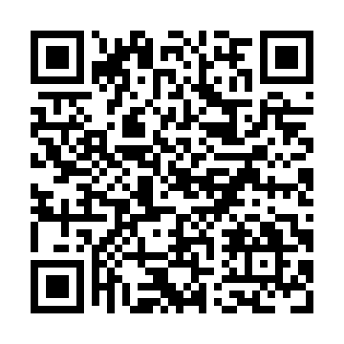
Prayer times for Armstrong Brook, New Brunswick, Canada
Wed 1 May 2024 - Fri 31 May 2024
High Latitude Method: Angle Based Rule
Prayer Calculation Method: Islamic Society of North America
Asar Calculation Method: Hanafi

Date | Day | Fajr | Sunrise | Dhuhr | Asr | Maghrib | Isha
1 | Wed | 4:22 | 6:05 | 1:21 | 6:24 | 8:38 | 10:21
2 | Thu | 4:20 | 6:03 | 1:21 | 6:25 | 8:39 | 10:23
3 | Fri | 4:18 | 6:02 | 1:21 | 6:26 | 8:40 | 10:25
4 | Sat | 4:15 | 6:00 | 1:21 | 6:27 | 8:42 | 10:27
5 | Sun | 4:13 | 5:59 | 1:21 | 6:28 | 8:43 | 10:29
6 | Mon | 4:11 | 5:57 | 1:20 | 6:29 | 8:44 | 10:31
7 | Tue | 4:09 | 5:56 | 1:20 | 6:29 | 8:46 | 10:33
8 | Wed | 4:06 | 5:54 | 1:20 | 6:30 | 8:47 | 10:35
9 | Thu | 4:04 | 5:53 | 1:20 | 6:31 | 8:49 | 10:38
10 | Fri | 4:02 | 5:51 | 1:20 | 6:32 | 8:50 | 10:40
11 | Sat | 4:00 | 5:50 | 1:20 | 6:33 | 8:51 | 10:42
12 | Sun | 3:58 | 5:49 | 1:20 | 6:33 | 8:53 | 10:44
13 | Mon | 3:56 | 5:47 | 1:20 | 6:34 | 8:54 | 10:46
14 | Tue | 3:53 | 5:46 | 1:20 | 6:35 | 8:55 | 10:48
15 | Wed | 3:51 | 5:45 | 1:20 | 6:36 | 8:56 | 10:50
16 | Thu | 3:49 | 5:43 | 1:20 | 6:36 | 8:58 | 10:52
17 | Fri | 3:47 | 5:42 | 1:20 | 6:37 | 8:59 | 10:54
18 | Sat | 3:45 | 5:41 | 1:20 | 6:38 | 9:00 | 10:57
19 | Sun | 3:43 | 5:40 | 1:20 | 6:39 | 9:01 | 10:59
20 | Mon | 3:41 | 5:39 | 1:20 | 6:39 | 9:03 | 11:01
21 | Tue | 3:39 | 5:38 | 1:21 | 6:40 | 9:04 | 11:03
22 | Wed | 3:38 | 5:37 | 1:21 | 6:41 | 9:05 | 11:05
23 | Thu | 3:36 | 5:36 | 1:21 | 6:42 | 9:06 | 11:07
24 | Fri | 3:34 | 5:35 | 1:21 | 6:42 | 9:07 | 11:09
25 | Sat | 3:32 | 5:34 | 1:21 | 6:43 | 9:08 | 11:11
26 | Sun | 3:30 | 5:33 | 1:21 | 6:44 | 9:09 | 11:13
27 | Mon | 3:29 | 5:32 | 1:21 | 6:44 | 9:11 | 11:14
28 | Tue | 3:27 | 5:31 | 1:21 | 6:45 | 9:12 | 11:16
29 | Wed | 3:26 | 5:31 | 1:21 | 6:45 | 9:13 | 11:17
30 | Thu | 3:26 | 5:30 | 1:22 | 6:46 | 9:14 | 11:18
31 | Fri | 3:26 | 5:29 | 1:22 | 6:47 | 9:15 | 11:18
Prayer times provided by https://www.salahtimes.com

