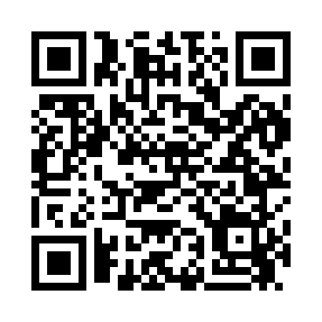
Prayer times for Achenbach, Connecticut, USA
Wed 1 May 2024 - Fri 31 May 2024
High Latitude Method: Angle Based Rule
Prayer Calculation Method: Islamic Society of North America
Asar Calculation Method: Shafi

Date | Day | Fajr | Sunrise | Dhuhr | Asr | Maghrib | Isha
1 | Wed | 4:20 | 5:47 | 12:48 | 4:40 | 7:49 | 9:17
2 | Thu | 4:18 | 5:46 | 12:48 | 4:41 | 7:50 | 9:18
3 | Fri | 4:17 | 5:44 | 12:48 | 4:41 | 7:52 | 9:19
4 | Sat | 4:15 | 5:43 | 12:48 | 4:41 | 7:53 | 9:21
5 | Sun | 4:13 | 5:42 | 12:47 | 4:42 | 7:54 | 9:22
6 | Mon | 4:12 | 5:41 | 12:47 | 4:42 | 7:55 | 9:24
7 | Tue | 4:10 | 5:39 | 12:47 | 4:42 | 7:56 | 9:25
8 | Wed | 4:09 | 5:38 | 12:47 | 4:43 | 7:57 | 9:27
9 | Thu | 4:07 | 5:37 | 12:47 | 4:43 | 7:58 | 9:28
10 | Fri | 4:06 | 5:36 | 12:47 | 4:43 | 7:59 | 9:30
11 | Sat | 4:04 | 5:35 | 12:47 | 4:43 | 8:00 | 9:31
12 | Sun | 4:03 | 5:34 | 12:47 | 4:44 | 8:01 | 9:33
13 | Mon | 4:01 | 5:33 | 12:47 | 4:44 | 8:02 | 9:34
14 | Tue | 4:00 | 5:32 | 12:47 | 4:44 | 8:03 | 9:35
15 | Wed | 3:58 | 5:31 | 12:47 | 4:45 | 8:04 | 9:37
16 | Thu | 3:57 | 5:30 | 12:47 | 4:45 | 8:05 | 9:38
17 | Fri | 3:56 | 5:29 | 12:47 | 4:45 | 8:06 | 9:40
18 | Sat | 3:54 | 5:28 | 12:47 | 4:46 | 8:07 | 9:41
19 | Sun | 3:53 | 5:27 | 12:47 | 4:46 | 8:08 | 9:42
20 | Mon | 3:52 | 5:26 | 12:47 | 4:46 | 8:09 | 9:44
21 | Tue | 3:51 | 5:26 | 12:47 | 4:46 | 8:10 | 9:45
22 | Wed | 3:49 | 5:25 | 12:48 | 4:47 | 8:11 | 9:46
23 | Thu | 3:48 | 5:24 | 12:48 | 4:47 | 8:12 | 9:48
24 | Fri | 3:47 | 5:23 | 12:48 | 4:47 | 8:12 | 9:49
25 | Sat | 3:46 | 5:23 | 12:48 | 4:48 | 8:13 | 9:50
26 | Sun | 3:45 | 5:22 | 12:48 | 4:48 | 8:14 | 9:52
27 | Mon | 3:44 | 5:21 | 12:48 | 4:48 | 8:15 | 9:53
28 | Tue | 3:43 | 5:21 | 12:48 | 4:49 | 8:16 | 9:54
29 | Wed | 3:42 | 5:20 | 12:48 | 4:49 | 8:17 | 9:55
30 | Thu | 3:41 | 5:20 | 12:48 | 4:49 | 8:18 | 9:56
31 | Fri | 3:40 | 5:19 | 12:49 | 4:49 | 8:18 | 9:57
Prayer times provided by https://www.salahtimes.com

