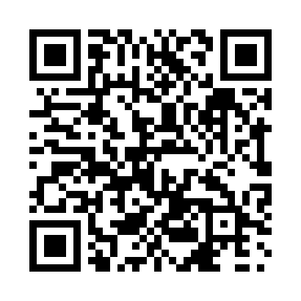
Prayer times for Glenlochar, Manitoba, Canada
Wed 1 May 2024 - Fri 31 May 2024
High Latitude Method: Angle Based Rule
Prayer Calculation Method: Islamic Society of North America
Asar Calculation Method: Hanafi

Date | Day | Fajr | Sunrise | Dhuhr | Asr | Maghrib | Isha
1 | Wed | 4:28 | 6:19 | 1:41 | 6:47 | 9:04 | 10:55
2 | Thu | 4:25 | 6:17 | 1:41 | 6:48 | 9:05 | 10:58
3 | Fri | 4:23 | 6:15 | 1:41 | 6:49 | 9:07 | 11:00
4 | Sat | 4:20 | 6:13 | 1:41 | 6:50 | 9:09 | 11:02
5 | Sun | 4:17 | 6:12 | 1:41 | 6:51 | 9:10 | 11:05
6 | Mon | 4:15 | 6:10 | 1:40 | 6:52 | 9:12 | 11:07
7 | Tue | 4:12 | 6:09 | 1:40 | 6:52 | 9:13 | 11:10
8 | Wed | 4:10 | 6:07 | 1:40 | 6:53 | 9:15 | 11:12
9 | Thu | 4:07 | 6:05 | 1:40 | 6:54 | 9:16 | 11:15
10 | Fri | 4:04 | 6:04 | 1:40 | 6:55 | 9:17 | 11:17
11 | Sat | 4:02 | 6:02 | 1:40 | 6:56 | 9:19 | 11:20
12 | Sun | 3:59 | 6:01 | 1:40 | 6:57 | 9:20 | 11:23
13 | Mon | 3:57 | 5:59 | 1:40 | 6:58 | 9:22 | 11:25
14 | Tue | 3:54 | 5:58 | 1:40 | 6:59 | 9:23 | 11:28
15 | Wed | 3:52 | 5:57 | 1:40 | 6:59 | 9:25 | 11:30
16 | Thu | 3:49 | 5:55 | 1:40 | 7:00 | 9:26 | 11:33
17 | Fri | 3:47 | 5:54 | 1:40 | 7:01 | 9:27 | 11:34
18 | Sat | 3:47 | 5:53 | 1:40 | 7:02 | 9:29 | 11:35
19 | Sun | 3:46 | 5:51 | 1:40 | 7:03 | 9:30 | 11:35
20 | Mon | 3:45 | 5:50 | 1:40 | 7:03 | 9:31 | 11:36
21 | Tue | 3:45 | 5:49 | 1:41 | 7:04 | 9:33 | 11:37
22 | Wed | 3:44 | 5:48 | 1:41 | 7:05 | 9:34 | 11:37
23 | Thu | 3:44 | 5:47 | 1:41 | 7:06 | 9:35 | 11:38
24 | Fri | 3:43 | 5:46 | 1:41 | 7:06 | 9:37 | 11:39
25 | Sat | 3:43 | 5:45 | 1:41 | 7:07 | 9:38 | 11:39
26 | Sun | 3:42 | 5:44 | 1:41 | 7:08 | 9:39 | 11:40
27 | Mon | 3:42 | 5:43 | 1:41 | 7:09 | 9:40 | 11:41
28 | Tue | 3:42 | 5:42 | 1:41 | 7:09 | 9:41 | 11:41
29 | Wed | 3:41 | 5:41 | 1:41 | 7:10 | 9:42 | 11:42
30 | Thu | 3:41 | 5:40 | 1:42 | 7:11 | 9:43 | 11:43
31 | Fri | 3:41 | 5:39 | 1:42 | 7:11 | 9:44 | 11:43
Prayer times provided by https://www.salahtimes.com

