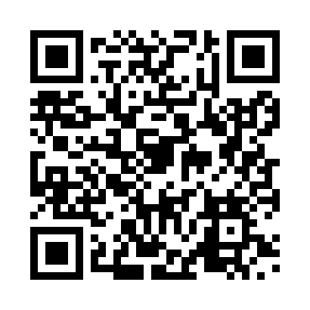
Prayer times for Decan, Kosovo
Wed 1 May 2024 - Fri 31 May 2024
High Latitude Method: None
Prayer Calculation Method: Muslim World League
Asar Calculation Method: Shafi

Date | Day | Fajr | Sunrise | Dhuhr | Asr | Maghrib | Isha
1 | Wed | 3:43 | 5:33 | 12:36 | 4:29 | 7:39 | 9:22
2 | Thu | 3:41 | 5:32 | 12:36 | 4:30 | 7:40 | 9:24
3 | Fri | 3:39 | 5:31 | 12:36 | 4:30 | 7:41 | 9:26
4 | Sat | 3:38 | 5:29 | 12:36 | 4:30 | 7:43 | 9:27
5 | Sun | 3:36 | 5:28 | 12:36 | 4:31 | 7:44 | 9:29
6 | Mon | 3:34 | 5:27 | 12:35 | 4:31 | 7:45 | 9:30
7 | Tue | 3:32 | 5:26 | 12:35 | 4:31 | 7:46 | 9:32
8 | Wed | 3:30 | 5:24 | 12:35 | 4:32 | 7:47 | 9:34
9 | Thu | 3:28 | 5:23 | 12:35 | 4:32 | 7:48 | 9:35
10 | Fri | 3:26 | 5:22 | 12:35 | 4:32 | 7:49 | 9:37
11 | Sat | 3:25 | 5:21 | 12:35 | 4:33 | 7:50 | 9:39
12 | Sun | 3:23 | 5:20 | 12:35 | 4:33 | 7:51 | 9:40
13 | Mon | 3:21 | 5:19 | 12:35 | 4:33 | 7:52 | 9:42
14 | Tue | 3:19 | 5:18 | 12:35 | 4:34 | 7:53 | 9:44
15 | Wed | 3:18 | 5:17 | 12:35 | 4:34 | 7:54 | 9:45
16 | Thu | 3:16 | 5:16 | 12:35 | 4:34 | 7:55 | 9:47
17 | Fri | 3:14 | 5:15 | 12:35 | 4:35 | 7:56 | 9:49
18 | Sat | 3:13 | 5:14 | 12:35 | 4:35 | 7:57 | 9:50
19 | Sun | 3:11 | 5:13 | 12:35 | 4:35 | 7:58 | 9:52
20 | Mon | 3:10 | 5:12 | 12:35 | 4:36 | 7:59 | 9:53
21 | Tue | 3:08 | 5:11 | 12:35 | 4:36 | 8:00 | 9:55
22 | Wed | 3:07 | 5:10 | 12:36 | 4:36 | 8:01 | 9:56
23 | Thu | 3:05 | 5:09 | 12:36 | 4:37 | 8:02 | 9:58
24 | Fri | 3:04 | 5:09 | 12:36 | 4:37 | 8:03 | 9:59
25 | Sat | 3:03 | 5:08 | 12:36 | 4:37 | 8:04 | 10:01
26 | Sun | 3:01 | 5:07 | 12:36 | 4:38 | 8:05 | 10:02
27 | Mon | 3:00 | 5:07 | 12:36 | 4:38 | 8:06 | 10:04
28 | Tue | 2:59 | 5:06 | 12:36 | 4:38 | 8:07 | 10:05
29 | Wed | 2:57 | 5:05 | 12:36 | 4:39 | 8:08 | 10:06
30 | Thu | 2:56 | 5:05 | 12:36 | 4:39 | 8:08 | 10:08
31 | Fri | 2:55 | 5:04 | 12:37 | 4:39 | 8:09 | 10:09
Prayer times provided by https://www.salahtimes.com

