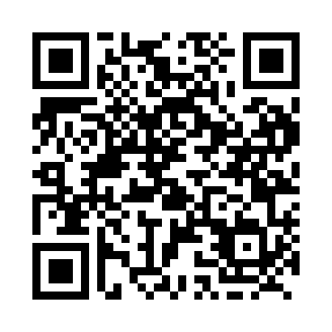
Prayer times for Davis, Saskatchewan, Canada
Mon 1 Apr 2024 - Tue 30 Apr 2024
High Latitude Method: Angle Based Rule
Prayer Calculation Method: Islamic Society of North America
Asar Calculation Method: Hanafi

Date | Day | Fajr | Sunrise | Dhuhr | Asr | Maghrib | Isha
1 | Mon | 4:54 | 6:35 | 1:06 | 5:33 | 7:39 | 9:20
2 | Tue | 4:51 | 6:32 | 1:06 | 5:34 | 7:41 | 9:22
3 | Wed | 4:48 | 6:30 | 1:06 | 5:36 | 7:42 | 9:24
4 | Thu | 4:45 | 6:28 | 1:05 | 5:37 | 7:44 | 9:27
5 | Fri | 4:43 | 6:25 | 1:05 | 5:38 | 7:46 | 9:29
6 | Sat | 4:40 | 6:23 | 1:05 | 5:40 | 7:48 | 9:31
7 | Sun | 4:37 | 6:20 | 1:05 | 5:41 | 7:50 | 9:34
8 | Mon | 4:34 | 6:18 | 1:04 | 5:42 | 7:51 | 9:36
9 | Tue | 4:31 | 6:16 | 1:04 | 5:43 | 7:53 | 9:38
10 | Wed | 4:28 | 6:13 | 1:04 | 5:45 | 7:55 | 9:41
11 | Thu | 4:25 | 6:11 | 1:03 | 5:46 | 7:57 | 9:43
12 | Fri | 4:22 | 6:09 | 1:03 | 5:47 | 7:59 | 9:46
13 | Sat | 4:19 | 6:07 | 1:03 | 5:48 | 8:00 | 9:48
14 | Sun | 4:16 | 6:04 | 1:03 | 5:50 | 8:02 | 9:51
15 | Mon | 4:13 | 6:02 | 1:02 | 5:51 | 8:04 | 9:53
16 | Tue | 4:10 | 6:00 | 1:02 | 5:52 | 8:06 | 9:56
17 | Wed | 4:07 | 5:57 | 1:02 | 5:53 | 8:08 | 9:59
18 | Thu | 4:04 | 5:55 | 1:02 | 5:54 | 8:09 | 10:01
19 | Fri | 4:01 | 5:53 | 1:02 | 5:56 | 8:11 | 10:04
20 | Sat | 3:58 | 5:51 | 1:01 | 5:57 | 8:13 | 10:07
21 | Sun | 3:55 | 5:49 | 1:01 | 5:58 | 8:15 | 10:09
22 | Mon | 3:51 | 5:46 | 1:01 | 5:59 | 8:16 | 10:12
23 | Tue | 3:48 | 5:44 | 1:01 | 6:00 | 8:18 | 10:15
24 | Wed | 3:45 | 5:42 | 1:01 | 6:01 | 8:20 | 10:18
25 | Thu | 3:42 | 5:40 | 1:00 | 6:02 | 8:22 | 10:21
26 | Fri | 3:39 | 5:38 | 1:00 | 6:04 | 8:24 | 10:23
27 | Sat | 3:36 | 5:36 | 1:00 | 6:05 | 8:25 | 10:26
28 | Sun | 3:32 | 5:34 | 1:00 | 6:06 | 8:27 | 10:29
29 | Mon | 3:29 | 5:32 | 1:00 | 6:07 | 8:29 | 10:32
30 | Tue | 3:26 | 5:30 | 1:00 | 6:08 | 8:31 | 10:35
Prayer times provided by https://www.salahtimes.com

