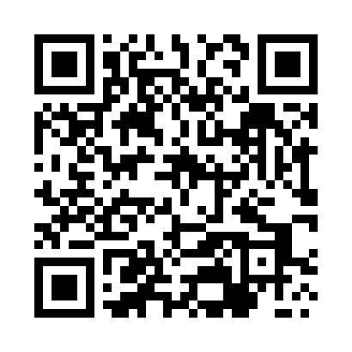
Prayer times for Oleksowka, Poland
Wed 1 May 2024 - Fri 31 May 2024
High Latitude Method: Angle Based Rule
Prayer Calculation Method: Muslim World League
Asar Calculation Method: Hanafi

Date | Day | Fajr | Sunrise | Dhuhr | Asr | Maghrib | Isha
1 | Wed | 3:00 | 5:17 | 12:37 | 5:42 | 7:58 | 10:05
2 | Thu | 2:57 | 5:15 | 12:37 | 5:43 | 7:59 | 10:08
3 | Fri | 2:54 | 5:13 | 12:37 | 5:44 | 8:01 | 10:11
4 | Sat | 2:51 | 5:12 | 12:36 | 5:45 | 8:02 | 10:13
5 | Sun | 2:48 | 5:10 | 12:36 | 5:45 | 8:04 | 10:16
6 | Mon | 2:44 | 5:08 | 12:36 | 5:46 | 8:05 | 10:19
7 | Tue | 2:41 | 5:07 | 12:36 | 5:47 | 8:06 | 10:21
8 | Wed | 2:38 | 5:05 | 12:36 | 5:48 | 8:08 | 10:24
9 | Thu | 2:35 | 5:04 | 12:36 | 5:49 | 8:09 | 10:27
10 | Fri | 2:32 | 5:02 | 12:36 | 5:50 | 8:11 | 10:30
11 | Sat | 2:29 | 5:01 | 12:36 | 5:51 | 8:12 | 10:32
12 | Sun | 2:26 | 4:59 | 12:36 | 5:52 | 8:14 | 10:35
13 | Mon | 2:23 | 4:58 | 12:36 | 5:52 | 8:15 | 10:38
14 | Tue | 2:20 | 4:56 | 12:36 | 5:53 | 8:16 | 10:41
15 | Wed | 2:20 | 4:55 | 12:36 | 5:54 | 8:18 | 10:44
16 | Thu | 2:19 | 4:54 | 12:36 | 5:55 | 8:19 | 10:45
17 | Fri | 2:19 | 4:52 | 12:36 | 5:56 | 8:21 | 10:46
18 | Sat | 2:18 | 4:51 | 12:36 | 5:56 | 8:22 | 10:46
19 | Sun | 2:18 | 4:50 | 12:36 | 5:57 | 8:23 | 10:47
20 | Mon | 2:17 | 4:49 | 12:36 | 5:58 | 8:25 | 10:47
21 | Tue | 2:17 | 4:48 | 12:36 | 5:59 | 8:26 | 10:48
22 | Wed | 2:17 | 4:46 | 12:36 | 5:59 | 8:27 | 10:49
23 | Thu | 2:16 | 4:45 | 12:37 | 6:00 | 8:28 | 10:49
24 | Fri | 2:16 | 4:44 | 12:37 | 6:01 | 8:29 | 10:50
25 | Sat | 2:16 | 4:43 | 12:37 | 6:02 | 8:31 | 10:50
26 | Sun | 2:15 | 4:42 | 12:37 | 6:02 | 8:32 | 10:51
27 | Mon | 2:15 | 4:41 | 12:37 | 6:03 | 8:33 | 10:51
28 | Tue | 2:15 | 4:41 | 12:37 | 6:04 | 8:34 | 10:52
29 | Wed | 2:14 | 4:40 | 12:37 | 6:04 | 8:35 | 10:52
30 | Thu | 2:14 | 4:39 | 12:37 | 6:05 | 8:36 | 10:53
31 | Fri | 2:14 | 4:38 | 12:38 | 6:06 | 8:37 | 10:54
Prayer times provided by https://www.salahtimes.com

