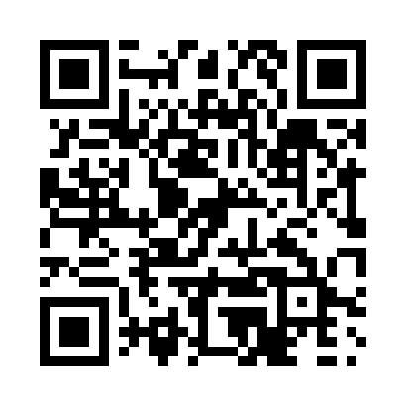

**Prayer times for Balfour, British Columbia, Canada**

**Thu 1 Aug 2024 - Sat 31 Aug 2024**

**High Latitude Method: Angle Based Rule**

**Prayer Calculation Method: Islamic Society of North America**

**Asar Calculation Method: Hanafi**

|  |  |  |  |  |  |  |  |
| --- | --- | --- | --- | --- | --- | --- | --- |
| **Date** | **Day** | **Fajr** | **Sunrise** | **Dhuhr** | **Asr** | **Maghrib** | **Isha** |
| 1 | Thu | 3:23 | 5:20 | 12:54 | 6:08 | 8:28 | 10:24 |
| 2 | Fri | 3:25 | 5:21 | 12:54 | 6:07 | 8:26 | 10:22 |
| 3 | Sat | 3:27 | 5:22 | 12:54 | 6:06 | 8:25 | 10:19 |
| 4 | Sun | 3:30 | 5:24 | 12:54 | 6:05 | 8:23 | 10:17 |
| 5 | Mon | 3:32 | 5:25 | 12:54 | 6:04 | 8:22 | 10:14 |
| 6 | Tue | 3:34 | 5:27 | 12:54 | 6:02 | 8:20 | 10:12 |
| 7 | Wed | 3:37 | 5:28 | 12:54 | 6:01 | 8:18 | 10:09 |
| 8 | Thu | 3:39 | 5:30 | 12:53 | 6:00 | 8:17 | 10:07 |
| 9 | Fri | 3:41 | 5:31 | 12:53 | 5:59 | 8:15 | 10:04 |
| 10 | Sat | 3:43 | 5:32 | 12:53 | 5:58 | 8:13 | 10:01 |
| 11 | Sun | 3:46 | 5:34 | 12:53 | 5:57 | 8:11 | 9:59 |
| 12 | Mon | 3:48 | 5:35 | 12:53 | 5:55 | 8:09 | 9:56 |
| 13 | Tue | 3:50 | 5:37 | 12:53 | 5:54 | 8:08 | 9:54 |
| 14 | Wed | 3:52 | 5:38 | 12:52 | 5:53 | 8:06 | 9:51 |
| 15 | Thu | 3:55 | 5:40 | 12:52 | 5:52 | 8:04 | 9:49 |
| 16 | Fri | 3:57 | 5:41 | 12:52 | 5:50 | 8:02 | 9:46 |
| 17 | Sat | 3:59 | 5:43 | 12:52 | 5:49 | 8:00 | 9:43 |
| 18 | Sun | 4:01 | 5:44 | 12:52 | 5:48 | 7:58 | 9:41 |
| 19 | Mon | 4:03 | 5:45 | 12:51 | 5:46 | 7:56 | 9:38 |
| 20 | Tue | 4:05 | 5:47 | 12:51 | 5:45 | 7:54 | 9:36 |
| 21 | Wed | 4:07 | 5:48 | 12:51 | 5:43 | 7:52 | 9:33 |
| 22 | Thu | 4:09 | 5:50 | 12:51 | 5:42 | 7:50 | 9:30 |
| 23 | Fri | 4:11 | 5:51 | 12:50 | 5:40 | 7:48 | 9:28 |
| 24 | Sat | 4:13 | 5:53 | 12:50 | 5:39 | 7:46 | 9:25 |
| 25 | Sun | 4:15 | 5:54 | 12:50 | 5:37 | 7:44 | 9:23 |
| 26 | Mon | 4:17 | 5:56 | 12:49 | 5:36 | 7:42 | 9:20 |
| 27 | Tue | 4:19 | 5:57 | 12:49 | 5:34 | 7:40 | 9:18 |
| 28 | Wed | 4:21 | 5:59 | 12:49 | 5:33 | 7:38 | 9:15 |
| 29 | Thu | 4:23 | 6:00 | 12:49 | 5:31 | 7:36 | 9:12 |
| 30 | Fri | 4:25 | 6:02 | 12:48 | 5:30 | 7:34 | 9:10 |
| 31 | Sat | 4:27 | 6:03 | 12:48 | 5:28 | 7:32 | 9:07 |

**Prayer times provided by https://www.salahtimes.com**