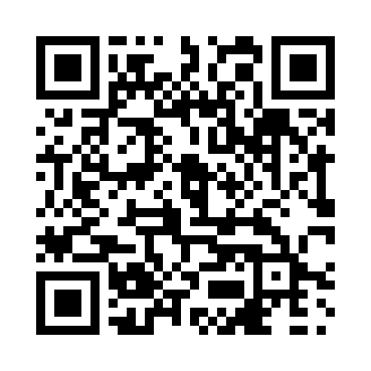
Prayer times for Agawa Bay, Ontario, Canada
Wed 1 May 2024 - Fri 31 May 2024
High Latitude Method: Angle Based Rule
Prayer Calculation Method: Islamic Society of North America
Asar Calculation Method: Hanafi

Date | Day | Fajr | Sunrise | Dhuhr | Asr | Maghrib | Isha
1 | Wed | 4:40 | 6:21 | 1:36 | 6:38 | 8:51 | 10:32
2 | Thu | 4:38 | 6:19 | 1:35 | 6:39 | 8:52 | 10:34
3 | Fri | 4:36 | 6:18 | 1:35 | 6:40 | 8:53 | 10:36
4 | Sat | 4:33 | 6:16 | 1:35 | 6:41 | 8:55 | 10:38
5 | Sun | 4:31 | 6:15 | 1:35 | 6:42 | 8:56 | 10:40
6 | Mon | 4:29 | 6:13 | 1:35 | 6:43 | 8:58 | 10:42
7 | Tue | 4:27 | 6:12 | 1:35 | 6:43 | 8:59 | 10:44
8 | Wed | 4:25 | 6:10 | 1:35 | 6:44 | 9:00 | 10:46
9 | Thu | 4:23 | 6:09 | 1:35 | 6:45 | 9:01 | 10:48
10 | Fri | 4:21 | 6:08 | 1:35 | 6:46 | 9:03 | 10:50
11 | Sat | 4:18 | 6:06 | 1:35 | 6:47 | 9:04 | 10:52
12 | Sun | 4:16 | 6:05 | 1:35 | 6:47 | 9:05 | 10:54
13 | Mon | 4:14 | 6:04 | 1:35 | 6:48 | 9:07 | 10:56
14 | Tue | 4:12 | 6:02 | 1:35 | 6:49 | 9:08 | 10:58
15 | Wed | 4:10 | 6:01 | 1:35 | 6:50 | 9:09 | 11:01
16 | Thu | 4:08 | 6:00 | 1:35 | 6:50 | 9:10 | 11:03
17 | Fri | 4:06 | 5:59 | 1:35 | 6:51 | 9:12 | 11:05
18 | Sat | 4:05 | 5:58 | 1:35 | 6:52 | 9:13 | 11:07
19 | Sun | 4:03 | 5:57 | 1:35 | 6:52 | 9:14 | 11:08
20 | Mon | 4:01 | 5:56 | 1:35 | 6:53 | 9:15 | 11:10
21 | Tue | 3:59 | 5:54 | 1:35 | 6:54 | 9:16 | 11:12
22 | Wed | 3:57 | 5:53 | 1:35 | 6:54 | 9:18 | 11:14
23 | Thu | 3:55 | 5:53 | 1:35 | 6:55 | 9:19 | 11:16
24 | Fri | 3:54 | 5:52 | 1:35 | 6:56 | 9:20 | 11:18
25 | Sat | 3:52 | 5:51 | 1:36 | 6:56 | 9:21 | 11:20
26 | Sun | 3:50 | 5:50 | 1:36 | 6:57 | 9:22 | 11:22
27 | Mon | 3:49 | 5:49 | 1:36 | 6:58 | 9:23 | 11:24
28 | Tue | 3:47 | 5:48 | 1:36 | 6:58 | 9:24 | 11:25
29 | Wed | 3:46 | 5:48 | 1:36 | 6:59 | 9:25 | 11:27
30 | Thu | 3:44 | 5:47 | 1:36 | 7:00 | 9:26 | 11:29
31 | Fri | 3:43 | 5:46 | 1:36 | 7:00 | 9:27 | 11:30
Prayer times provided by https://www.salahtimes.com

