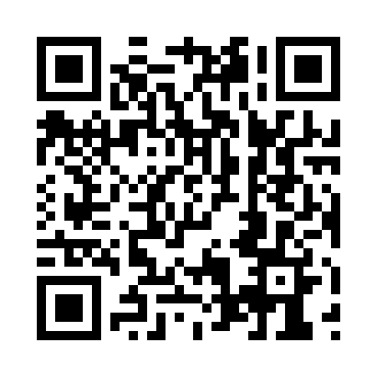
Prayer times for Barlow, Yukon, Canada
Wed 1 May 2024 - Fri 31 May 2024
High Latitude Method: Angle Based Rule
Prayer Calculation Method: Islamic Society of North America
Asar Calculation Method: Hanafi

Date | Day | Fajr | Sunrise | Dhuhr | Asr | Maghrib | Isha
1 | Wed | 3:56 | 5:43 | 2:08 | 7:32 | 10:34 | 12:21
2 | Thu | 3:54 | 5:40 | 2:08 | 7:34 | 10:37 | 12:23
3 | Fri | 3:52 | 5:36 | 2:07 | 7:35 | 10:40 | 12:24
4 | Sat | 3:51 | 5:33 | 2:07 | 7:37 | 10:43 | 12:26
5 | Sun | 3:49 | 5:30 | 2:07 | 7:39 | 10:46 | 12:27
6 | Mon | 3:47 | 5:26 | 2:07 | 7:40 | 10:50 | 12:29
7 | Tue | 3:46 | 5:23 | 2:07 | 7:42 | 10:53 | 12:30
8 | Wed | 3:44 | 5:20 | 2:07 | 7:43 | 10:56 | 12:32
9 | Thu | 3:42 | 5:17 | 2:07 | 7:45 | 10:59 | 12:33
10 | Fri | 3:41 | 5:13 | 2:07 | 7:47 | 11:02 | 12:35
11 | Sat | 3:39 | 5:10 | 2:07 | 7:48 | 11:05 | 12:37
12 | Sun | 3:37 | 5:07 | 2:07 | 7:50 | 11:08 | 12:38
13 | Mon | 3:36 | 5:04 | 2:07 | 7:51 | 11:12 | 12:40
14 | Tue | 3:34 | 5:01 | 2:07 | 7:53 | 11:15 | 12:41
15 | Wed | 3:33 | 4:58 | 2:07 | 7:54 | 11:18 | 12:43
16 | Thu | 3:31 | 4:55 | 2:07 | 7:56 | 11:21 | 12:44
17 | Fri | 3:30 | 4:52 | 2:07 | 7:57 | 11:24 | 12:46
18 | Sat | 3:28 | 4:49 | 2:07 | 7:58 | 11:27 | 12:48
19 | Sun | 3:27 | 4:46 | 2:07 | 8:00 | 11:30 | 12:49
20 | Mon | 3:25 | 4:43 | 2:07 | 8:01 | 11:33 | 12:51
21 | Tue | 3:24 | 4:40 | 2:07 | 8:02 | 11:36 | 12:52
22 | Wed | 3:22 | 4:37 | 2:07 | 8:04 | 11:39 | 12:54
23 | Thu | 3:21 | 4:34 | 2:07 | 8:05 | 11:42 | 12:55
24 | Fri | 3:20 | 4:31 | 2:08 | 8:06 | 11:45 | 12:57
25 | Sat | 3:18 | 4:28 | 2:08 | 8:07 | 11:48 | 12:58
26 | Sun | 3:17 | 4:26 | 2:08 | 8:09 | 11:51 | 1:00
27 | Mon | 3:16 | 4:23 | 2:08 | 8:10 | 11:54 | 1:01
28 | Tue | 3:15 | 4:21 | 2:08 | 8:11 | 11:57 | 1:03
29 | Wed | 3:13 | 4:18 | 2:08 | 8:12 | 12:00 | 1:04
30 | Thu | 3:12 | 4:16 | 2:08 | 8:13 | 12:02 | 1:06
31 | Fri | 3:11 | 4:13 | 2:08 | 8:14 | 12:05 | 1:07
Prayer times provided by https://www.salahtimes.com

