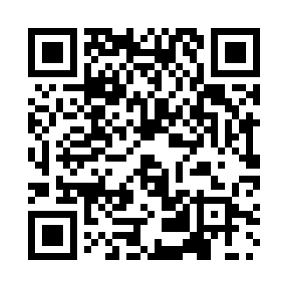
Prayer times for Ellikom, Belgium
Mon 1 Apr 2024 - Tue 30 Apr 2024
High Latitude Method: Angle Based Rule
Prayer Calculation Method: Muslim World League
Asar Calculation Method: Shafi

Date | Day | Fajr | Sunrise | Dhuhr | Asr | Maghrib | Isha
1 | Mon | 5:15 | 7:13 | 1:42 | 5:15 | 8:12 | 10:02
2 | Tue | 5:12 | 7:10 | 1:41 | 5:16 | 8:13 | 10:04
3 | Wed | 5:10 | 7:08 | 1:41 | 5:17 | 8:15 | 10:06
4 | Thu | 5:07 | 7:06 | 1:41 | 5:18 | 8:16 | 10:08
5 | Fri | 5:04 | 7:04 | 1:40 | 5:18 | 8:18 | 10:11
6 | Sat | 5:01 | 7:02 | 1:40 | 5:19 | 8:20 | 10:13
7 | Sun | 4:58 | 6:59 | 1:40 | 5:20 | 8:21 | 10:15
8 | Mon | 4:55 | 6:57 | 1:40 | 5:21 | 8:23 | 10:17
9 | Tue | 4:52 | 6:55 | 1:39 | 5:22 | 8:25 | 10:20
10 | Wed | 4:50 | 6:53 | 1:39 | 5:22 | 8:26 | 10:22
11 | Thu | 4:47 | 6:51 | 1:39 | 5:23 | 8:28 | 10:24
12 | Fri | 4:44 | 6:48 | 1:39 | 5:24 | 8:30 | 10:27
13 | Sat | 4:41 | 6:46 | 1:38 | 5:25 | 8:31 | 10:29
14 | Sun | 4:38 | 6:44 | 1:38 | 5:26 | 8:33 | 10:31
15 | Mon | 4:35 | 6:42 | 1:38 | 5:26 | 8:35 | 10:34
16 | Tue | 4:32 | 6:40 | 1:38 | 5:27 | 8:36 | 10:36
17 | Wed | 4:29 | 6:38 | 1:37 | 5:28 | 8:38 | 10:39
18 | Thu | 4:25 | 6:36 | 1:37 | 5:29 | 8:39 | 10:41
19 | Fri | 4:22 | 6:34 | 1:37 | 5:29 | 8:41 | 10:44
20 | Sat | 4:19 | 6:32 | 1:37 | 5:30 | 8:43 | 10:46
21 | Sun | 4:16 | 6:30 | 1:37 | 5:31 | 8:44 | 10:49
22 | Mon | 4:13 | 6:28 | 1:36 | 5:31 | 8:46 | 10:52
23 | Tue | 4:10 | 6:26 | 1:36 | 5:32 | 8:48 | 10:54
24 | Wed | 4:06 | 6:24 | 1:36 | 5:33 | 8:49 | 10:57
25 | Thu | 4:03 | 6:22 | 1:36 | 5:34 | 8:51 | 11:00
26 | Fri | 4:00 | 6:20 | 1:36 | 5:34 | 8:53 | 11:03
27 | Sat | 3:57 | 6:18 | 1:35 | 5:35 | 8:54 | 11:05
28 | Sun | 3:53 | 6:16 | 1:35 | 5:36 | 8:56 | 11:08
29 | Mon | 3:50 | 6:14 | 1:35 | 5:36 | 8:57 | 11:11
30 | Tue | 3:47 | 6:12 | 1:35 | 5:37 | 8:59 | 11:14
Prayer times provided by https://www.salahtimes.com

