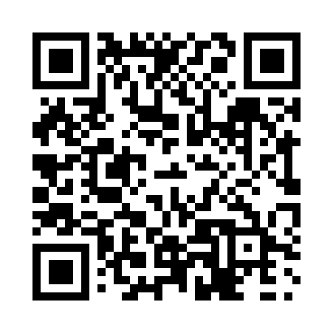
Prayer times for Sheshatshiu, Newfoundland and Labrador, Canada
Mon 1 Jul 2024 - Wed 31 Jul 2024
High Latitude Method: Angle Based Rule
Prayer Calculation Method: Islamic Society of North America
Asar Calculation Method: Hanafi

Date | Day | Fajr | Sunrise | Dhuhr | Asr | Maghrib | Isha
1 | Mon | 2:50 | 4:36 | 1:05 | 6:45 | 9:32 | 11:18
2 | Tue | 2:51 | 4:37 | 1:05 | 6:45 | 9:32 | 11:18
3 | Wed | 2:51 | 4:38 | 1:05 | 6:45 | 9:32 | 11:18
4 | Thu | 2:52 | 4:39 | 1:05 | 6:45 | 9:31 | 11:18
5 | Fri | 2:53 | 4:40 | 1:05 | 6:45 | 9:30 | 11:18
6 | Sat | 2:53 | 4:41 | 1:06 | 6:44 | 9:30 | 11:17
7 | Sun | 2:54 | 4:42 | 1:06 | 6:44 | 9:29 | 11:17
8 | Mon | 2:54 | 4:43 | 1:06 | 6:44 | 9:28 | 11:17
9 | Tue | 2:55 | 4:44 | 1:06 | 6:43 | 9:27 | 11:17
10 | Wed | 2:56 | 4:45 | 1:06 | 6:43 | 9:26 | 11:16
11 | Thu | 2:56 | 4:46 | 1:06 | 6:43 | 9:26 | 11:16
12 | Fri | 2:57 | 4:48 | 1:06 | 6:42 | 9:25 | 11:15
13 | Sat | 2:58 | 4:49 | 1:06 | 6:42 | 9:24 | 11:15
14 | Sun | 2:58 | 4:50 | 1:07 | 6:41 | 9:22 | 11:14
15 | Mon | 2:59 | 4:51 | 1:07 | 6:41 | 9:21 | 11:14
16 | Tue | 3:00 | 4:53 | 1:07 | 6:40 | 9:20 | 11:13
17 | Wed | 3:00 | 4:54 | 1:07 | 6:39 | 9:19 | 11:13
18 | Thu | 3:01 | 4:56 | 1:07 | 6:39 | 9:18 | 11:12
19 | Fri | 3:02 | 4:57 | 1:07 | 6:38 | 9:16 | 11:11
20 | Sat | 3:03 | 4:58 | 1:07 | 6:37 | 9:15 | 11:11
21 | Sun | 3:03 | 5:00 | 1:07 | 6:37 | 9:14 | 11:10
22 | Mon | 3:04 | 5:01 | 1:07 | 6:36 | 9:12 | 11:09
23 | Tue | 3:05 | 5:03 | 1:07 | 6:35 | 9:11 | 11:09
24 | Wed | 3:06 | 5:04 | 1:07 | 6:34 | 9:09 | 11:08
25 | Thu | 3:06 | 5:06 | 1:07 | 6:33 | 9:08 | 11:07
26 | Fri | 3:07 | 5:07 | 1:07 | 6:32 | 9:06 | 11:06
27 | Sat | 3:08 | 5:09 | 1:07 | 6:31 | 9:04 | 11:06
28 | Sun | 3:09 | 5:11 | 1:07 | 6:30 | 9:03 | 11:05
29 | Mon | 3:09 | 5:12 | 1:07 | 6:29 | 9:01 | 11:04
30 | Tue | 3:10 | 5:14 | 1:07 | 6:28 | 8:59 | 11:03
31 | Wed | 3:11 | 5:16 | 1:07 | 6:27 | 8:58 | 11:02
Prayer times provided by https://www.salahtimes.com

