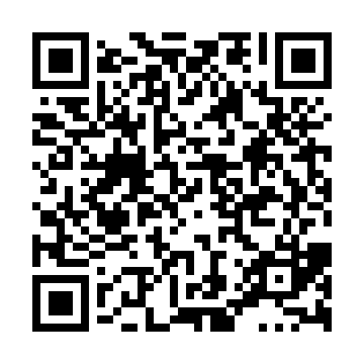
Prayer times for Greenfield Park, Quebec, Canada
Mon 1 Apr 2024 - Tue 30 Apr 2024
High Latitude Method: Angle Based Rule
Prayer Calculation Method: Islamic Society of North America
Asar Calculation Method: Hanafi

Date | Day | Fajr | Sunrise | Dhuhr | Asr | Maghrib | Isha
1 | Mon | 5:09 | 6:33 | 12:58 | 5:27 | 7:23 | 8:47
2 | Tue | 5:07 | 6:31 | 12:57 | 5:28 | 7:24 | 8:49
3 | Wed | 5:05 | 6:29 | 12:57 | 5:29 | 7:25 | 8:50
4 | Thu | 5:03 | 6:28 | 12:57 | 5:30 | 7:27 | 8:52
5 | Fri | 5:01 | 6:26 | 12:56 | 5:31 | 7:28 | 8:53
6 | Sat | 4:58 | 6:24 | 12:56 | 5:31 | 7:29 | 8:55
7 | Sun | 4:56 | 6:22 | 12:56 | 5:32 | 7:31 | 8:56
8 | Mon | 4:54 | 6:20 | 12:56 | 5:33 | 7:32 | 8:58
9 | Tue | 4:52 | 6:18 | 12:55 | 5:34 | 7:33 | 9:00
10 | Wed | 4:50 | 6:16 | 12:55 | 5:35 | 7:34 | 9:01
11 | Thu | 4:48 | 6:15 | 12:55 | 5:36 | 7:36 | 9:03
12 | Fri | 4:46 | 6:13 | 12:55 | 5:37 | 7:37 | 9:04
13 | Sat | 4:43 | 6:11 | 12:54 | 5:37 | 7:38 | 9:06
14 | Sun | 4:41 | 6:09 | 12:54 | 5:38 | 7:40 | 9:08
15 | Mon | 4:39 | 6:07 | 12:54 | 5:39 | 7:41 | 9:09
16 | Tue | 4:37 | 6:06 | 12:54 | 5:40 | 7:42 | 9:11
17 | Wed | 4:35 | 6:04 | 12:53 | 5:41 | 7:43 | 9:13
18 | Thu | 4:33 | 6:02 | 12:53 | 5:42 | 7:45 | 9:14
19 | Fri | 4:31 | 6:01 | 12:53 | 5:42 | 7:46 | 9:16
20 | Sat | 4:28 | 5:59 | 12:53 | 5:43 | 7:47 | 9:18
21 | Sun | 4:26 | 5:57 | 12:52 | 5:44 | 7:49 | 9:20
22 | Mon | 4:24 | 5:55 | 12:52 | 5:45 | 7:50 | 9:21
23 | Tue | 4:22 | 5:54 | 12:52 | 5:46 | 7:51 | 9:23
24 | Wed | 4:20 | 5:52 | 12:52 | 5:46 | 7:52 | 9:25
25 | Thu | 4:18 | 5:51 | 12:52 | 5:47 | 7:54 | 9:27
26 | Fri | 4:16 | 5:49 | 12:52 | 5:48 | 7:55 | 9:28
27 | Sat | 4:14 | 5:47 | 12:51 | 5:49 | 7:56 | 9:30
28 | Sun | 4:12 | 5:46 | 12:51 | 5:50 | 7:58 | 9:32
29 | Mon | 4:10 | 5:44 | 12:51 | 5:50 | 7:59 | 9:34
30 | Tue | 4:08 | 5:43 | 12:51 | 5:51 | 8:00 | 9:36
Prayer times provided by https://www.salahtimes.com

