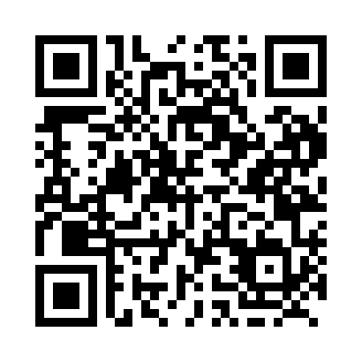
Prayer times for Albas, British Columbia, Canada
Mon 1 Jul 2024 - Wed 31 Jul 2024
High Latitude Method: Angle Based Rule
Prayer Calculation Method: Islamic Society of North America
Asar Calculation Method: Hanafi

Date | Day | Fajr | Sunrise | Dhuhr | Asr | Maghrib | Isha
1 | Mon | 2:53 | 4:45 | 1:00 | 6:35 | 9:15 | 11:07
2 | Tue | 2:53 | 4:46 | 1:00 | 6:35 | 9:14 | 11:07
3 | Wed | 2:54 | 4:47 | 1:00 | 6:35 | 9:14 | 11:07
4 | Thu | 2:54 | 4:48 | 1:01 | 6:35 | 9:13 | 11:07
5 | Fri | 2:55 | 4:49 | 1:01 | 6:35 | 9:13 | 11:07
6 | Sat | 2:55 | 4:49 | 1:01 | 6:35 | 9:12 | 11:06
7 | Sun | 2:56 | 4:50 | 1:01 | 6:34 | 9:12 | 11:06
8 | Mon | 2:56 | 4:51 | 1:01 | 6:34 | 9:11 | 11:06
9 | Tue | 2:57 | 4:52 | 1:01 | 6:34 | 9:10 | 11:06
10 | Wed | 2:57 | 4:53 | 1:02 | 6:33 | 9:09 | 11:05
11 | Thu | 2:58 | 4:54 | 1:02 | 6:33 | 9:09 | 11:05
12 | Fri | 2:59 | 4:56 | 1:02 | 6:33 | 9:08 | 11:05
13 | Sat | 2:59 | 4:57 | 1:02 | 6:32 | 9:07 | 11:04
14 | Sun | 3:00 | 4:58 | 1:02 | 6:32 | 9:06 | 11:04
15 | Mon | 3:00 | 4:59 | 1:02 | 6:31 | 9:05 | 11:03
16 | Tue | 3:01 | 5:00 | 1:02 | 6:31 | 9:04 | 11:03
17 | Wed | 3:02 | 5:01 | 1:02 | 6:30 | 9:03 | 11:02
18 | Thu | 3:02 | 5:03 | 1:02 | 6:30 | 9:02 | 11:02
19 | Fri | 3:03 | 5:04 | 1:02 | 6:29 | 9:00 | 11:01
20 | Sat | 3:04 | 5:05 | 1:03 | 6:28 | 8:59 | 11:01
21 | Sun | 3:04 | 5:07 | 1:03 | 6:28 | 8:58 | 11:00
22 | Mon | 3:05 | 5:08 | 1:03 | 6:27 | 8:57 | 10:59
23 | Tue | 3:06 | 5:09 | 1:03 | 6:26 | 8:55 | 10:59
24 | Wed | 3:06 | 5:11 | 1:03 | 6:25 | 8:54 | 10:58
25 | Thu | 3:07 | 5:12 | 1:03 | 6:25 | 8:53 | 10:57
26 | Fri | 3:08 | 5:13 | 1:03 | 6:24 | 8:51 | 10:57
27 | Sat | 3:09 | 5:15 | 1:03 | 6:23 | 8:50 | 10:56
28 | Sun | 3:09 | 5:16 | 1:03 | 6:22 | 8:48 | 10:55
29 | Mon | 3:10 | 5:18 | 1:03 | 6:21 | 8:47 | 10:54
30 | Tue | 3:11 | 5:19 | 1:02 | 6:20 | 8:45 | 10:52
31 | Wed | 3:14 | 5:21 | 1:02 | 6:19 | 8:43 | 10:49
Prayer times provided by https://www.salahtimes.com

