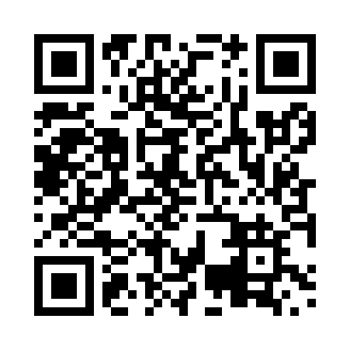
Prayer times for Inuksulik, Quebec, Canada
Mon 1 Jul 2024 - Wed 31 Jul 2024
High Latitude Method: Angle Based Rule
Prayer Calculation Method: Islamic Society of North America
Asar Calculation Method: Hanafi

Date | Day | Fajr | Sunrise | Dhuhr | Asr | Maghrib | Isha
1 | Mon | 1:56 | 3:09 | 12:43 | 6:45 | 10:15 | 11:29
2 | Tue | 1:57 | 3:11 | 12:43 | 6:44 | 10:14 | 11:28
3 | Wed | 1:57 | 3:12 | 12:43 | 6:44 | 10:13 | 11:28
4 | Thu | 1:58 | 3:13 | 12:43 | 6:44 | 10:12 | 11:28
5 | Fri | 1:59 | 3:15 | 12:43 | 6:43 | 10:11 | 11:27
6 | Sat | 2:00 | 3:17 | 12:43 | 6:43 | 10:10 | 11:26
7 | Sun | 2:01 | 3:18 | 12:44 | 6:43 | 10:08 | 11:26
8 | Mon | 2:02 | 3:20 | 12:44 | 6:42 | 10:07 | 11:25
9 | Tue | 2:03 | 3:22 | 12:44 | 6:41 | 10:05 | 11:24
10 | Wed | 2:04 | 3:24 | 12:44 | 6:41 | 10:04 | 11:24
11 | Thu | 2:05 | 3:25 | 12:44 | 6:40 | 10:02 | 11:23
12 | Fri | 2:06 | 3:27 | 12:44 | 6:40 | 10:00 | 11:22
13 | Sat | 2:07 | 3:29 | 12:44 | 6:39 | 9:59 | 11:21
14 | Sun | 2:08 | 3:31 | 12:45 | 6:38 | 9:57 | 11:20
15 | Mon | 2:09 | 3:34 | 12:45 | 6:37 | 9:55 | 11:19
16 | Tue | 2:10 | 3:36 | 12:45 | 6:36 | 9:53 | 11:19
17 | Wed | 2:11 | 3:38 | 12:45 | 6:36 | 9:51 | 11:18
18 | Thu | 2:12 | 3:40 | 12:45 | 6:35 | 9:49 | 11:16
19 | Fri | 2:13 | 3:42 | 12:45 | 6:34 | 9:46 | 11:15
20 | Sat | 2:15 | 3:45 | 12:45 | 6:33 | 9:44 | 11:14
21 | Sun | 2:16 | 3:47 | 12:45 | 6:32 | 9:42 | 11:13
22 | Mon | 2:17 | 3:49 | 12:45 | 6:30 | 9:40 | 11:12
23 | Tue | 2:18 | 3:52 | 12:45 | 6:29 | 9:37 | 11:11
24 | Wed | 2:19 | 3:54 | 12:45 | 6:28 | 9:35 | 11:10
25 | Thu | 2:20 | 3:56 | 12:45 | 6:27 | 9:33 | 11:09
26 | Fri | 2:22 | 3:59 | 12:45 | 6:26 | 9:30 | 11:07
27 | Sat | 2:23 | 4:01 | 12:45 | 6:24 | 9:28 | 11:06
28 | Sun | 2:24 | 4:04 | 12:45 | 6:23 | 9:25 | 11:05
29 | Mon | 2:25 | 4:06 | 12:45 | 6:22 | 9:23 | 11:03
30 | Tue | 2:27 | 4:09 | 12:45 | 6:20 | 9:20 | 11:02
31 | Wed | 2:28 | 4:11 | 12:45 | 6:19 | 9:17 | 11:01
Prayer times provided by https://www.salahtimes.com

