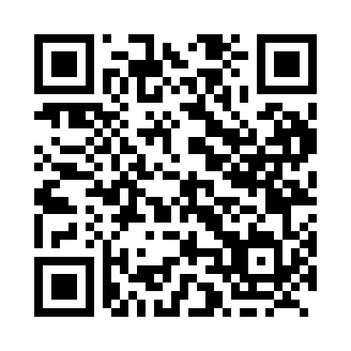

**Prayer times for Natikamaukau, Quebec, Canada**

**Sun 1 Sep 2024 - Mon 30 Sep 2024**

**High Latitude Method: Angle Based Rule**

**Prayer Calculation Method: Islamic Society of North America**

**Asar Calculation Method: Hanafi**

|  |  |  |  |  |  |  |  |
| --- | --- | --- | --- | --- | --- | --- | --- |
| **Date** | **Day** | **Fajr** | **Sunrise** | **Dhuhr** | **Asr** | **Maghrib** | **Isha** |
| 1 | Sun | 3:26 | 5:24 | 12:19 | 4:58 | 7:13 | 9:10 |
| 2 | Mon | 3:29 | 5:26 | 12:18 | 4:56 | 7:10 | 9:06 |
| 3 | Tue | 3:32 | 5:28 | 12:18 | 4:54 | 7:07 | 9:03 |
| 4 | Wed | 3:35 | 5:30 | 12:18 | 4:52 | 7:05 | 8:59 |
| 5 | Thu | 3:37 | 5:32 | 12:17 | 4:50 | 7:02 | 8:56 |
| 6 | Fri | 3:40 | 5:34 | 12:17 | 4:47 | 6:59 | 8:53 |
| 7 | Sat | 3:43 | 5:36 | 12:17 | 4:45 | 6:57 | 8:49 |
| 8 | Sun | 3:45 | 5:38 | 12:16 | 4:43 | 6:54 | 8:46 |
| 9 | Mon | 3:48 | 5:40 | 12:16 | 4:41 | 6:51 | 8:43 |
| 10 | Tue | 3:51 | 5:42 | 12:16 | 4:39 | 6:49 | 8:39 |
| 11 | Wed | 3:53 | 5:43 | 12:15 | 4:37 | 6:46 | 8:36 |
| 12 | Thu | 3:56 | 5:45 | 12:15 | 4:35 | 6:43 | 8:33 |
| 13 | Fri | 3:58 | 5:47 | 12:15 | 4:32 | 6:41 | 8:30 |
| 14 | Sat | 4:01 | 5:49 | 12:14 | 4:30 | 6:38 | 8:26 |
| 15 | Sun | 4:03 | 5:51 | 12:14 | 4:28 | 6:35 | 8:23 |
| 16 | Mon | 4:06 | 5:53 | 12:14 | 4:26 | 6:33 | 8:20 |
| 17 | Tue | 4:08 | 5:55 | 12:13 | 4:24 | 6:30 | 8:17 |
| 18 | Wed | 4:10 | 5:57 | 12:13 | 4:21 | 6:27 | 8:14 |
| 19 | Thu | 4:13 | 5:59 | 12:13 | 4:19 | 6:25 | 8:11 |
| 20 | Fri | 4:15 | 6:01 | 12:12 | 4:17 | 6:22 | 8:08 |
| 21 | Sat | 4:17 | 6:03 | 12:12 | 4:14 | 6:19 | 8:05 |
| 22 | Sun | 4:20 | 6:05 | 12:11 | 4:12 | 6:16 | 8:02 |
| 23 | Mon | 4:22 | 6:07 | 12:11 | 4:10 | 6:14 | 7:59 |
| 24 | Tue | 4:24 | 6:09 | 12:11 | 4:08 | 6:11 | 7:56 |
| 25 | Wed | 4:27 | 6:11 | 12:10 | 4:05 | 6:08 | 7:53 |
| 26 | Thu | 4:29 | 6:13 | 12:10 | 4:03 | 6:06 | 7:50 |
| 27 | Fri | 4:31 | 6:15 | 12:10 | 4:01 | 6:03 | 7:47 |
| 28 | Sat | 4:33 | 6:17 | 12:09 | 3:58 | 6:00 | 7:44 |
| 29 | Sun | 4:35 | 6:19 | 12:09 | 3:56 | 5:58 | 7:41 |
| 30 | Mon | 4:38 | 6:21 | 12:09 | 3:54 | 5:55 | 7:39 |

**Prayer times provided by https://www.salahtimes.com**