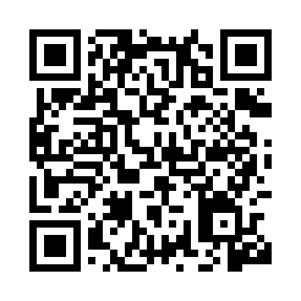

**Prayer times for Botoşani, Botosani, Romania**

**Fri 1 Nov 2024 - Sat 30 Nov 2024**

**High Latitude Method: Angle Based Rule**

**Prayer Calculation Method: Muslim World League**

**Asar Calculation Method: Hanafi**

|  |  |  |  |  |  |  |  |
| --- | --- | --- | --- | --- | --- | --- | --- |
| **Date** | **Day** | **Fajr** | **Sunrise** | **Dhuhr** | **Asr** | **Maghrib** | **Isha** |
| 1 | Fri | 5:13 | 6:58 | 11:57 | 3:09 | 4:55 | 6:34 |
| 2 | Sat | 5:15 | 7:00 | 11:57 | 3:08 | 4:53 | 6:32 |
| 3 | Sun | 5:16 | 7:01 | 11:57 | 3:06 | 4:52 | 6:31 |
| 4 | Mon | 5:17 | 7:03 | 11:57 | 3:05 | 4:50 | 6:30 |
| 5 | Tue | 5:19 | 7:04 | 11:57 | 3:03 | 4:49 | 6:29 |
| 6 | Wed | 5:20 | 7:06 | 11:57 | 3:02 | 4:48 | 6:27 |
| 7 | Thu | 5:21 | 7:07 | 11:57 | 3:01 | 4:46 | 6:26 |
| 8 | Fri | 5:23 | 7:09 | 11:57 | 2:59 | 4:45 | 6:25 |
| 9 | Sat | 5:24 | 7:10 | 11:57 | 2:58 | 4:43 | 6:24 |
| 10 | Sun | 5:25 | 7:12 | 11:57 | 2:57 | 4:42 | 6:23 |
| 11 | Mon | 5:26 | 7:13 | 11:57 | 2:56 | 4:41 | 6:22 |
| 12 | Tue | 5:28 | 7:15 | 11:58 | 2:54 | 4:40 | 6:21 |
| 13 | Wed | 5:29 | 7:16 | 11:58 | 2:53 | 4:38 | 6:20 |
| 14 | Thu | 5:30 | 7:18 | 11:58 | 2:52 | 4:37 | 6:19 |
| 15 | Fri | 5:32 | 7:19 | 11:58 | 2:51 | 4:36 | 6:18 |
| 16 | Sat | 5:33 | 7:21 | 11:58 | 2:50 | 4:35 | 6:17 |
| 17 | Sun | 5:34 | 7:22 | 11:58 | 2:49 | 4:34 | 6:16 |
| 18 | Mon | 5:35 | 7:24 | 11:59 | 2:48 | 4:33 | 6:15 |
| 19 | Tue | 5:37 | 7:25 | 11:59 | 2:47 | 4:32 | 6:14 |
| 20 | Wed | 5:38 | 7:27 | 11:59 | 2:46 | 4:31 | 6:14 |
| 21 | Thu | 5:39 | 7:28 | 11:59 | 2:45 | 4:30 | 6:13 |
| 22 | Fri | 5:40 | 7:29 | 12:00 | 2:44 | 4:29 | 6:12 |
| 23 | Sat | 5:41 | 7:31 | 12:00 | 2:44 | 4:28 | 6:12 |
| 24 | Sun | 5:42 | 7:32 | 12:00 | 2:43 | 4:27 | 6:11 |
| 25 | Mon | 5:44 | 7:34 | 12:00 | 2:42 | 4:27 | 6:11 |
| 26 | Tue | 5:45 | 7:35 | 12:01 | 2:41 | 4:26 | 6:10 |
| 27 | Wed | 5:46 | 7:36 | 12:01 | 2:41 | 4:25 | 6:10 |
| 28 | Thu | 5:47 | 7:38 | 12:01 | 2:40 | 4:25 | 6:09 |
| 29 | Fri | 5:48 | 7:39 | 12:02 | 2:40 | 4:24 | 6:09 |
| 30 | Sat | 5:49 | 7:40 | 12:02 | 2:39 | 4:24 | 6:09 |

**Prayer times provided by https://www.salahtimes.com**