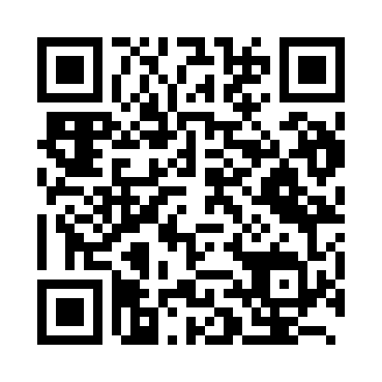
Prayer times for Kagoshima, Japan
Wed 1 May 2024 - Fri 31 May 2024
High Latitude Method: None
Prayer Calculation Method: Muslim World League
Asar Calculation Method: Shafi

Date | Day | Fajr | Sunrise | Dhuhr | Asr | Maghrib | Isha
1 | Wed | 4:04 | 5:33 | 12:15 | 3:54 | 6:58 | 8:21
2 | Thu | 4:02 | 5:32 | 12:15 | 3:54 | 6:58 | 8:22
3 | Fri | 4:01 | 5:31 | 12:15 | 3:54 | 6:59 | 8:23
4 | Sat | 4:00 | 5:30 | 12:15 | 3:54 | 7:00 | 8:24
5 | Sun | 3:59 | 5:29 | 12:14 | 3:54 | 7:00 | 8:25
6 | Mon | 3:58 | 5:28 | 12:14 | 3:54 | 7:01 | 8:26
7 | Tue | 3:57 | 5:27 | 12:14 | 3:54 | 7:02 | 8:27
8 | Wed | 3:56 | 5:26 | 12:14 | 3:54 | 7:03 | 8:28
9 | Thu | 3:54 | 5:26 | 12:14 | 3:54 | 7:03 | 8:29
10 | Fri | 3:53 | 5:25 | 12:14 | 3:54 | 7:04 | 8:30
11 | Sat | 3:52 | 5:24 | 12:14 | 3:54 | 7:05 | 8:31
12 | Sun | 3:51 | 5:23 | 12:14 | 3:54 | 7:05 | 8:32
13 | Mon | 3:50 | 5:23 | 12:14 | 3:54 | 7:06 | 8:33
14 | Tue | 3:49 | 5:22 | 12:14 | 3:54 | 7:07 | 8:34
15 | Wed | 3:48 | 5:21 | 12:14 | 3:54 | 7:07 | 8:35
16 | Thu | 3:47 | 5:21 | 12:14 | 3:54 | 7:08 | 8:36
17 | Fri | 3:47 | 5:20 | 12:14 | 3:54 | 7:09 | 8:37
18 | Sat | 3:46 | 5:19 | 12:14 | 3:54 | 7:09 | 8:37
19 | Sun | 3:45 | 5:19 | 12:14 | 3:54 | 7:10 | 8:38
20 | Mon | 3:44 | 5:18 | 12:14 | 3:54 | 7:11 | 8:39
21 | Tue | 3:43 | 5:18 | 12:14 | 3:54 | 7:11 | 8:40
22 | Wed | 3:42 | 5:17 | 12:14 | 3:54 | 7:12 | 8:41
23 | Thu | 3:42 | 5:17 | 12:15 | 3:54 | 7:13 | 8:42
24 | Fri | 3:41 | 5:16 | 12:15 | 3:55 | 7:13 | 8:43
25 | Sat | 3:40 | 5:16 | 12:15 | 3:55 | 7:14 | 8:44
26 | Sun | 3:40 | 5:15 | 12:15 | 3:55 | 7:15 | 8:45
27 | Mon | 3:39 | 5:15 | 12:15 | 3:55 | 7:15 | 8:45
28 | Tue | 3:38 | 5:15 | 12:15 | 3:55 | 7:16 | 8:46
29 | Wed | 3:38 | 5:14 | 12:15 | 3:55 | 7:16 | 8:47
30 | Thu | 3:37 | 5:14 | 12:15 | 3:55 | 7:17 | 8:48
31 | Fri | 3:37 | 5:14 | 12:16 | 3:55 | 7:18 | 8:49
Prayer times provided by https://www.salahtimes.com

