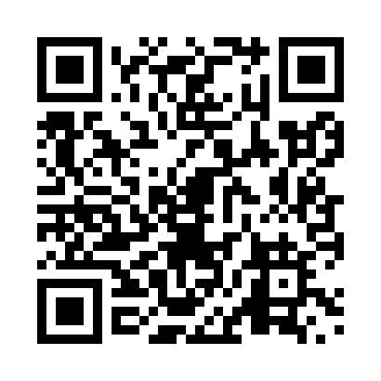
Prayer times for Lewis, Yukon, Canada
Wed 1 May 2024 - Fri 31 May 2024
High Latitude Method: Angle Based Rule
Prayer Calculation Method: Islamic Society of North America
Asar Calculation Method: Hanafi

Date | Day | Fajr | Sunrise | Dhuhr | Asr | Maghrib | Isha
1 | Wed | 3:55 | 5:53 | 1:56 | 7:15 | 10:01 | 11:59
2 | Thu | 3:54 | 5:50 | 1:56 | 7:17 | 10:03 | 12:00
3 | Fri | 3:52 | 5:48 | 1:56 | 7:18 | 10:06 | 12:01
4 | Sat | 3:51 | 5:45 | 1:56 | 7:19 | 10:08 | 12:03
5 | Sun | 3:49 | 5:42 | 1:56 | 7:21 | 10:11 | 12:04
6 | Mon | 3:48 | 5:40 | 1:56 | 7:22 | 10:13 | 12:05
7 | Tue | 3:47 | 5:37 | 1:56 | 7:24 | 10:16 | 12:06
8 | Wed | 3:45 | 5:34 | 1:56 | 7:25 | 10:18 | 12:07
9 | Thu | 3:44 | 5:32 | 1:56 | 7:26 | 10:21 | 12:09
10 | Fri | 3:43 | 5:29 | 1:56 | 7:28 | 10:23 | 12:10
11 | Sat | 3:41 | 5:27 | 1:56 | 7:29 | 10:26 | 12:11
12 | Sun | 3:40 | 5:24 | 1:56 | 7:30 | 10:28 | 12:12
13 | Mon | 3:39 | 5:22 | 1:56 | 7:32 | 10:31 | 12:13
14 | Tue | 3:38 | 5:19 | 1:56 | 7:33 | 10:33 | 12:15
15 | Wed | 3:37 | 5:17 | 1:56 | 7:34 | 10:36 | 12:16
16 | Thu | 3:35 | 5:15 | 1:56 | 7:36 | 10:38 | 12:17
17 | Fri | 3:34 | 5:12 | 1:56 | 7:37 | 10:40 | 12:18
18 | Sat | 3:33 | 5:10 | 1:56 | 7:38 | 10:43 | 12:19
19 | Sun | 3:32 | 5:08 | 1:56 | 7:39 | 10:45 | 12:21
20 | Mon | 3:31 | 5:06 | 1:56 | 7:40 | 10:47 | 12:22
21 | Tue | 3:30 | 5:04 | 1:56 | 7:41 | 10:49 | 12:23
22 | Wed | 3:29 | 5:01 | 1:56 | 7:43 | 10:52 | 12:24
23 | Thu | 3:28 | 4:59 | 1:56 | 7:44 | 10:54 | 12:25
24 | Fri | 3:27 | 4:57 | 1:56 | 7:45 | 10:56 | 12:26
25 | Sat | 3:26 | 4:56 | 1:56 | 7:46 | 10:58 | 12:27
26 | Sun | 3:25 | 4:54 | 1:56 | 7:47 | 11:00 | 12:29
27 | Mon | 3:24 | 4:52 | 1:57 | 7:48 | 11:02 | 12:30
28 | Tue | 3:24 | 4:50 | 1:57 | 7:49 | 11:04 | 12:31
29 | Wed | 3:23 | 4:48 | 1:57 | 7:50 | 11:06 | 12:32
30 | Thu | 3:22 | 4:47 | 1:57 | 7:51 | 11:08 | 12:33
31 | Fri | 3:21 | 4:45 | 1:57 | 7:52 | 11:10 | 12:34
Prayer times provided by https://www.salahtimes.com

