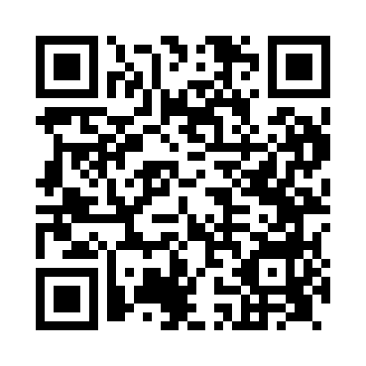
Prayer times for Bletsoe, Bedfordshire, UK
Wed 1 May 2024 - Fri 31 May 2024
High Latitude Method: Angle Based Rule
Prayer Calculation Method: Islamic Society of North America
Asar Calculation Method: Hanafi

Date | Day | Fajr | Sunrise | Dhuhr | Asr | Maghrib | Isha
1 | Wed | 3:31 | 5:31 | 12:59 | 6:07 | 8:28 | 10:29
2 | Thu | 3:28 | 5:29 | 12:59 | 6:08 | 8:30 | 10:32
3 | Fri | 3:25 | 5:27 | 12:59 | 6:09 | 8:32 | 10:35
4 | Sat | 3:22 | 5:25 | 12:59 | 6:10 | 8:33 | 10:37
5 | Sun | 3:19 | 5:23 | 12:59 | 6:11 | 8:35 | 10:40
6 | Mon | 3:15 | 5:22 | 12:59 | 6:12 | 8:37 | 10:43
7 | Tue | 3:12 | 5:20 | 12:59 | 6:13 | 8:38 | 10:46
8 | Wed | 3:09 | 5:18 | 12:58 | 6:14 | 8:40 | 10:49
9 | Thu | 3:08 | 5:16 | 12:58 | 6:15 | 8:41 | 10:50
10 | Fri | 3:07 | 5:15 | 12:58 | 6:16 | 8:43 | 10:51
11 | Sat | 3:06 | 5:13 | 12:58 | 6:17 | 8:45 | 10:52
12 | Sun | 3:05 | 5:11 | 12:58 | 6:18 | 8:46 | 10:53
13 | Mon | 3:04 | 5:10 | 12:58 | 6:19 | 8:48 | 10:53
14 | Tue | 3:03 | 5:08 | 12:58 | 6:20 | 8:49 | 10:54
15 | Wed | 3:03 | 5:07 | 12:58 | 6:21 | 8:51 | 10:55
16 | Thu | 3:02 | 5:05 | 12:58 | 6:22 | 8:52 | 10:56
17 | Fri | 3:01 | 5:04 | 12:58 | 6:23 | 8:54 | 10:56
18 | Sat | 3:00 | 5:02 | 12:58 | 6:23 | 8:55 | 10:57
19 | Sun | 3:00 | 5:01 | 12:59 | 6:24 | 8:57 | 10:58
20 | Mon | 2:59 | 4:59 | 12:59 | 6:25 | 8:58 | 10:59
21 | Tue | 2:59 | 4:58 | 12:59 | 6:26 | 9:00 | 10:59
22 | Wed | 2:58 | 4:57 | 12:59 | 6:27 | 9:01 | 11:00
23 | Thu | 2:57 | 4:56 | 12:59 | 6:28 | 9:03 | 11:01
24 | Fri | 2:57 | 4:54 | 12:59 | 6:28 | 9:04 | 11:02
25 | Sat | 2:56 | 4:53 | 12:59 | 6:29 | 9:05 | 11:02
26 | Sun | 2:56 | 4:52 | 12:59 | 6:30 | 9:07 | 11:03
27 | Mon | 2:55 | 4:51 | 12:59 | 6:31 | 9:08 | 11:04
28 | Tue | 2:55 | 4:50 | 12:59 | 6:31 | 9:09 | 11:04
29 | Wed | 2:54 | 4:49 | 12:59 | 6:32 | 9:10 | 11:05
30 | Thu | 2:54 | 4:48 | 1:00 | 6:33 | 9:12 | 11:06
31 | Fri | 2:54 | 4:47 | 1:00 | 6:34 | 9:13 | 11:06
Prayer times provided by https://www.salahtimes.com

