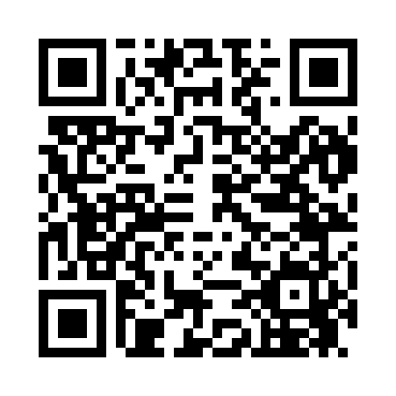
Prayer times for Bowlerville, Nevada, USA
Wed 1 May 2024 - Fri 31 May 2024
High Latitude Method: Angle Based Rule
Prayer Calculation Method: Islamic Society of North America
Asar Calculation Method: Shafi

Date | Day | Fajr | Sunrise | Dhuhr | Asr | Maghrib | Isha
1 | Wed | 4:32 | 5:50 | 12:41 | 4:27 | 7:33 | 8:52
2 | Thu | 4:30 | 5:49 | 12:41 | 4:27 | 7:34 | 8:53
3 | Fri | 4:29 | 5:48 | 12:41 | 4:28 | 7:35 | 8:54
4 | Sat | 4:28 | 5:47 | 12:41 | 4:28 | 7:35 | 8:55
5 | Sun | 4:26 | 5:46 | 12:41 | 4:28 | 7:36 | 8:56
6 | Mon | 4:25 | 5:45 | 12:41 | 4:28 | 7:37 | 8:57
7 | Tue | 4:24 | 5:44 | 12:41 | 4:28 | 7:38 | 8:58
8 | Wed | 4:22 | 5:43 | 12:41 | 4:28 | 7:39 | 9:00
9 | Thu | 4:21 | 5:42 | 12:41 | 4:29 | 7:40 | 9:01
10 | Fri | 4:20 | 5:41 | 12:41 | 4:29 | 7:41 | 9:02
11 | Sat | 4:19 | 5:40 | 12:41 | 4:29 | 7:41 | 9:03
12 | Sun | 4:18 | 5:39 | 12:41 | 4:29 | 7:42 | 9:04
13 | Mon | 4:17 | 5:38 | 12:41 | 4:29 | 7:43 | 9:05
14 | Tue | 4:15 | 5:38 | 12:41 | 4:29 | 7:44 | 9:06
15 | Wed | 4:14 | 5:37 | 12:41 | 4:29 | 7:45 | 9:07
16 | Thu | 4:13 | 5:36 | 12:41 | 4:30 | 7:46 | 9:08
17 | Fri | 4:12 | 5:35 | 12:41 | 4:30 | 7:46 | 9:10
18 | Sat | 4:11 | 5:35 | 12:41 | 4:30 | 7:47 | 9:11
19 | Sun | 4:10 | 5:34 | 12:41 | 4:30 | 7:48 | 9:12
20 | Mon | 4:09 | 5:33 | 12:41 | 4:30 | 7:49 | 9:13
21 | Tue | 4:08 | 5:33 | 12:41 | 4:30 | 7:49 | 9:14
22 | Wed | 4:08 | 5:32 | 12:41 | 4:31 | 7:50 | 9:15
23 | Thu | 4:07 | 5:31 | 12:41 | 4:31 | 7:51 | 9:16
24 | Fri | 4:06 | 5:31 | 12:41 | 4:31 | 7:52 | 9:17
25 | Sat | 4:05 | 5:30 | 12:41 | 4:31 | 7:52 | 9:18
26 | Sun | 4:04 | 5:30 | 12:41 | 4:31 | 7:53 | 9:19
27 | Mon | 4:04 | 5:29 | 12:41 | 4:32 | 7:54 | 9:20
28 | Tue | 4:03 | 5:29 | 12:42 | 4:32 | 7:55 | 9:21
29 | Wed | 4:02 | 5:28 | 12:42 | 4:32 | 7:55 | 9:22
30 | Thu | 4:02 | 5:28 | 12:42 | 4:32 | 7:56 | 9:23
31 | Fri | 4:01 | 5:28 | 12:42 | 4:32 | 7:57 | 9:23
Prayer times provided by https://www.salahtimes.com

