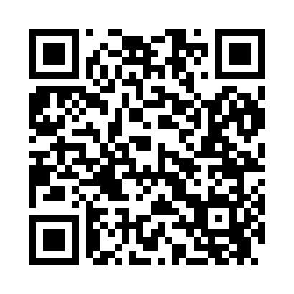
Prayer times for Snoqualmie Pass, Washington, USA
Mon 1 Jul 2024 - Wed 31 Jul 2024
High Latitude Method: Angle Based Rule
Prayer Calculation Method: Islamic Society of North America
Asar Calculation Method: Shafi

Date | Day | Fajr | Sunrise | Dhuhr | Asr | Maghrib | Isha
1 | Mon | 3:11 | 5:13 | 1:10 | 5:23 | 9:06 | 11:08
2 | Tue | 3:12 | 5:14 | 1:10 | 5:23 | 9:05 | 11:08
3 | Wed | 3:12 | 5:15 | 1:10 | 5:23 | 9:05 | 11:08
4 | Thu | 3:13 | 5:15 | 1:10 | 5:23 | 9:05 | 11:07
5 | Fri | 3:13 | 5:16 | 1:10 | 5:23 | 9:04 | 11:07
6 | Sat | 3:14 | 5:17 | 1:11 | 5:23 | 9:04 | 11:07
7 | Sun | 3:14 | 5:18 | 1:11 | 5:23 | 9:03 | 11:07
8 | Mon | 3:15 | 5:19 | 1:11 | 5:23 | 9:03 | 11:07
9 | Tue | 3:15 | 5:19 | 1:11 | 5:23 | 9:02 | 11:07
10 | Wed | 3:16 | 5:20 | 1:11 | 5:23 | 9:02 | 11:05
11 | Thu | 3:18 | 5:21 | 1:11 | 5:23 | 9:01 | 11:04
12 | Fri | 3:19 | 5:22 | 1:11 | 5:23 | 9:00 | 11:02
13 | Sat | 3:21 | 5:23 | 1:11 | 5:23 | 8:59 | 11:01
14 | Sun | 3:23 | 5:24 | 1:12 | 5:22 | 8:59 | 10:59
15 | Mon | 3:25 | 5:25 | 1:12 | 5:22 | 8:58 | 10:58
16 | Tue | 3:26 | 5:26 | 1:12 | 5:22 | 8:57 | 10:56
17 | Wed | 3:28 | 5:27 | 1:12 | 5:22 | 8:56 | 10:55
18 | Thu | 3:30 | 5:28 | 1:12 | 5:22 | 8:55 | 10:53
19 | Fri | 3:32 | 5:29 | 1:12 | 5:21 | 8:54 | 10:51
20 | Sat | 3:34 | 5:30 | 1:12 | 5:21 | 8:53 | 10:49
21 | Sun | 3:36 | 5:31 | 1:12 | 5:21 | 8:52 | 10:47
22 | Mon | 3:38 | 5:33 | 1:12 | 5:20 | 8:51 | 10:46
23 | Tue | 3:40 | 5:34 | 1:12 | 5:20 | 8:50 | 10:44
24 | Wed | 3:42 | 5:35 | 1:12 | 5:20 | 8:49 | 10:42
25 | Thu | 3:43 | 5:36 | 1:12 | 5:19 | 8:48 | 10:40
26 | Fri | 3:45 | 5:37 | 1:12 | 5:19 | 8:46 | 10:38
27 | Sat | 3:47 | 5:39 | 1:12 | 5:18 | 8:45 | 10:36
28 | Sun | 3:49 | 5:40 | 1:12 | 5:18 | 8:44 | 10:34
29 | Mon | 3:51 | 5:41 | 1:12 | 5:17 | 8:43 | 10:32
30 | Tue | 3:53 | 5:42 | 1:12 | 5:17 | 8:41 | 10:30
31 | Wed | 3:55 | 5:43 | 1:12 | 5:16 | 8:40 | 10:27
Prayer times provided by https://www.salahtimes.com

