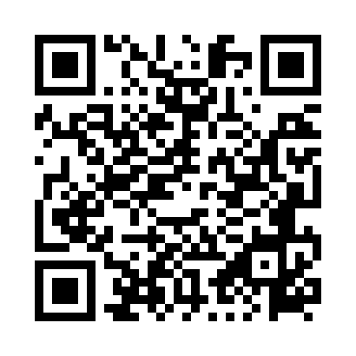
Prayer times for Lecka, Poland
Wed 1 May 2024 - Fri 31 May 2024
High Latitude Method: Angle Based Rule
Prayer Calculation Method: Muslim World League
Asar Calculation Method: Hanafi

Date | Day | Fajr | Sunrise | Dhuhr | Asr | Maghrib | Isha
1 | Wed | 2:49 | 5:08 | 12:29 | 5:34 | 7:51 | 10:00
2 | Thu | 2:46 | 5:06 | 12:29 | 5:35 | 7:52 | 10:03
3 | Fri | 2:43 | 5:05 | 12:29 | 5:36 | 7:54 | 10:06
4 | Sat | 2:40 | 5:03 | 12:29 | 5:37 | 7:55 | 10:08
5 | Sun | 2:36 | 5:01 | 12:29 | 5:38 | 7:57 | 10:11
6 | Mon | 2:33 | 5:00 | 12:29 | 5:39 | 7:58 | 10:14
7 | Tue | 2:30 | 4:58 | 12:28 | 5:40 | 8:00 | 10:17
8 | Wed | 2:27 | 4:56 | 12:28 | 5:41 | 8:01 | 10:20
9 | Thu | 2:24 | 4:55 | 12:28 | 5:42 | 8:03 | 10:22
10 | Fri | 2:20 | 4:53 | 12:28 | 5:43 | 8:04 | 10:25
11 | Sat | 2:17 | 4:52 | 12:28 | 5:43 | 8:06 | 10:28
12 | Sun | 2:14 | 4:50 | 12:28 | 5:44 | 8:07 | 10:31
13 | Mon | 2:13 | 4:49 | 12:28 | 5:45 | 8:09 | 10:34
14 | Tue | 2:12 | 4:47 | 12:28 | 5:46 | 8:10 | 10:37
15 | Wed | 2:12 | 4:46 | 12:28 | 5:47 | 8:11 | 10:37
16 | Thu | 2:11 | 4:45 | 12:28 | 5:48 | 8:13 | 10:38
17 | Fri | 2:11 | 4:43 | 12:28 | 5:48 | 8:14 | 10:38
18 | Sat | 2:10 | 4:42 | 12:28 | 5:49 | 8:15 | 10:39
19 | Sun | 2:10 | 4:41 | 12:28 | 5:50 | 8:17 | 10:40
20 | Mon | 2:09 | 4:40 | 12:29 | 5:51 | 8:18 | 10:40
21 | Tue | 2:09 | 4:38 | 12:29 | 5:52 | 8:19 | 10:41
22 | Wed | 2:08 | 4:37 | 12:29 | 5:52 | 8:21 | 10:41
23 | Thu | 2:08 | 4:36 | 12:29 | 5:53 | 8:22 | 10:42
24 | Fri | 2:08 | 4:35 | 12:29 | 5:54 | 8:23 | 10:43
25 | Sat | 2:07 | 4:34 | 12:29 | 5:54 | 8:24 | 10:43
26 | Sun | 2:07 | 4:33 | 12:29 | 5:55 | 8:26 | 10:44
27 | Mon | 2:07 | 4:32 | 12:29 | 5:56 | 8:27 | 10:44
28 | Tue | 2:06 | 4:31 | 12:29 | 5:57 | 8:28 | 10:45
29 | Wed | 2:06 | 4:30 | 12:29 | 5:57 | 8:29 | 10:45
30 | Thu | 2:06 | 4:30 | 12:30 | 5:58 | 8:30 | 10:46
31 | Fri | 2:05 | 4:29 | 12:30 | 5:59 | 8:31 | 10:46
Prayer times provided by https://www.salahtimes.com

