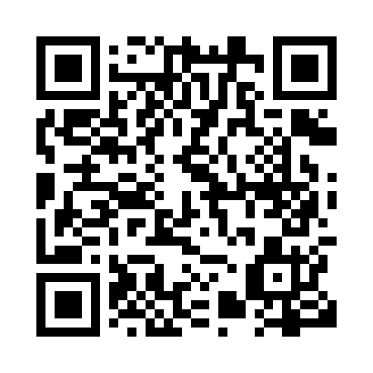
Prayer times for Tofino, British Columbia, Canada
Wed 1 May 2024 - Fri 31 May 2024
High Latitude Method: Angle Based Rule
Prayer Calculation Method: Islamic Society of North America
Asar Calculation Method: Hanafi

Date | Day | Fajr | Sunrise | Dhuhr | Asr | Maghrib | Isha
1 | Wed | 4:14 | 6:01 | 1:21 | 6:26 | 8:41 | 10:29
2 | Thu | 4:12 | 5:59 | 1:21 | 6:27 | 8:42 | 10:31
3 | Fri | 4:09 | 5:58 | 1:20 | 6:27 | 8:44 | 10:33
4 | Sat | 4:07 | 5:56 | 1:20 | 6:28 | 8:45 | 10:35
5 | Sun | 4:04 | 5:54 | 1:20 | 6:29 | 8:47 | 10:38
6 | Mon | 4:02 | 5:53 | 1:20 | 6:30 | 8:48 | 10:40
7 | Tue | 3:59 | 5:51 | 1:20 | 6:31 | 8:50 | 10:42
8 | Wed | 3:57 | 5:50 | 1:20 | 6:32 | 8:51 | 10:45
9 | Thu | 3:54 | 5:48 | 1:20 | 6:33 | 8:53 | 10:47
10 | Fri | 3:52 | 5:47 | 1:20 | 6:33 | 8:54 | 10:49
11 | Sat | 3:50 | 5:45 | 1:20 | 6:34 | 8:55 | 10:52
12 | Sun | 3:47 | 5:44 | 1:20 | 6:35 | 8:57 | 10:54
13 | Mon | 3:45 | 5:42 | 1:20 | 6:36 | 8:58 | 10:56
14 | Tue | 3:43 | 5:41 | 1:20 | 6:37 | 9:00 | 10:59
15 | Wed | 3:40 | 5:40 | 1:20 | 6:38 | 9:01 | 11:01
16 | Thu | 3:38 | 5:38 | 1:20 | 6:38 | 9:02 | 11:03
17 | Fri | 3:36 | 5:37 | 1:20 | 6:39 | 9:04 | 11:06
18 | Sat | 3:34 | 5:36 | 1:20 | 6:40 | 9:05 | 11:08
19 | Sun | 3:31 | 5:35 | 1:20 | 6:41 | 9:06 | 11:10
20 | Mon | 3:29 | 5:34 | 1:20 | 6:41 | 9:07 | 11:13
21 | Tue | 3:27 | 5:33 | 1:20 | 6:42 | 9:09 | 11:15
22 | Wed | 3:26 | 5:31 | 1:20 | 6:43 | 9:10 | 11:15
23 | Thu | 3:26 | 5:30 | 1:20 | 6:44 | 9:11 | 11:16
24 | Fri | 3:25 | 5:29 | 1:21 | 6:44 | 9:12 | 11:17
25 | Sat | 3:25 | 5:28 | 1:21 | 6:45 | 9:13 | 11:17
26 | Sun | 3:24 | 5:28 | 1:21 | 6:46 | 9:15 | 11:18
27 | Mon | 3:24 | 5:27 | 1:21 | 6:46 | 9:16 | 11:18
28 | Tue | 3:24 | 5:26 | 1:21 | 6:47 | 9:17 | 11:19
29 | Wed | 3:23 | 5:25 | 1:21 | 6:48 | 9:18 | 11:20
30 | Thu | 3:23 | 5:24 | 1:21 | 6:48 | 9:19 | 11:20
31 | Fri | 3:23 | 5:23 | 1:21 | 6:49 | 9:20 | 11:21
Prayer times provided by https://www.salahtimes.com

