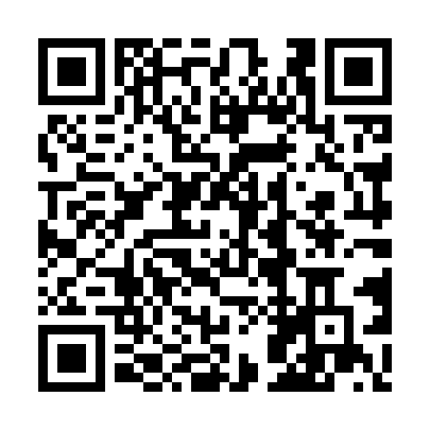
Prayer times for Barra de Sao Francisco, Brazil
Wed 1 May 2024 - Fri 31 May 2024
High Latitude Method: None
Prayer Calculation Method: Muslim World League
Asar Calculation Method: Shafi

Date | Day | Fajr | Sunrise | Dhuhr | Asr | Maghrib | Isha
1 | Wed | 4:44 | 5:58 | 11:41 | 2:57 | 5:23 | 6:33
2 | Thu | 4:44 | 5:59 | 11:40 | 2:57 | 5:22 | 6:33
3 | Fri | 4:44 | 5:59 | 11:40 | 2:56 | 5:22 | 6:32
4 | Sat | 4:44 | 5:59 | 11:40 | 2:56 | 5:21 | 6:32
5 | Sun | 4:45 | 6:00 | 11:40 | 2:56 | 5:21 | 6:31
6 | Mon | 4:45 | 6:00 | 11:40 | 2:55 | 5:20 | 6:31
7 | Tue | 4:45 | 6:00 | 11:40 | 2:55 | 5:20 | 6:31
8 | Wed | 4:45 | 6:01 | 11:40 | 2:55 | 5:19 | 6:30
9 | Thu | 4:46 | 6:01 | 11:40 | 2:55 | 5:19 | 6:30
10 | Fri | 4:46 | 6:01 | 11:40 | 2:54 | 5:18 | 6:30
11 | Sat | 4:46 | 6:02 | 11:40 | 2:54 | 5:18 | 6:29
12 | Sun | 4:46 | 6:02 | 11:40 | 2:54 | 5:18 | 6:29
13 | Mon | 4:47 | 6:02 | 11:40 | 2:53 | 5:17 | 6:29
14 | Tue | 4:47 | 6:03 | 11:40 | 2:53 | 5:17 | 6:28
15 | Wed | 4:47 | 6:03 | 11:40 | 2:53 | 5:17 | 6:28
16 | Thu | 4:47 | 6:03 | 11:40 | 2:53 | 5:16 | 6:28
17 | Fri | 4:48 | 6:04 | 11:40 | 2:53 | 5:16 | 6:28
18 | Sat | 4:48 | 6:04 | 11:40 | 2:52 | 5:16 | 6:28
19 | Sun | 4:48 | 6:05 | 11:40 | 2:52 | 5:15 | 6:27
20 | Mon | 4:48 | 6:05 | 11:40 | 2:52 | 5:15 | 6:27
21 | Tue | 4:49 | 6:05 | 11:40 | 2:52 | 5:15 | 6:27
22 | Wed | 4:49 | 6:06 | 11:40 | 2:52 | 5:15 | 6:27
23 | Thu | 4:49 | 6:06 | 11:40 | 2:52 | 5:15 | 6:27
24 | Fri | 4:50 | 6:06 | 11:40 | 2:52 | 5:14 | 6:27
25 | Sat | 4:50 | 6:07 | 11:41 | 2:51 | 5:14 | 6:27
26 | Sun | 4:50 | 6:07 | 11:41 | 2:51 | 5:14 | 6:27
27 | Mon | 4:51 | 6:08 | 11:41 | 2:51 | 5:14 | 6:27
28 | Tue | 4:51 | 6:08 | 11:41 | 2:51 | 5:14 | 6:27
29 | Wed | 4:51 | 6:08 | 11:41 | 2:51 | 5:14 | 6:26
30 | Thu | 4:51 | 6:09 | 11:41 | 2:51 | 5:14 | 6:26
31 | Fri | 4:52 | 6:09 | 11:41 | 2:51 | 5:14 | 6:26
Prayer times provided by https://www.salahtimes.com

