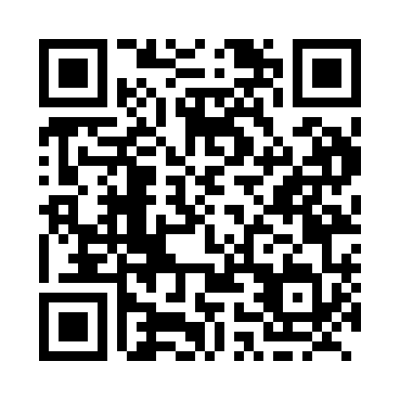
Prayer times for Alexo, Alberta, Canada
Wed 1 May 2024 - Fri 31 May 2024
High Latitude Method: Angle Based Rule
Prayer Calculation Method: Islamic Society of North America
Asar Calculation Method: Hanafi

Date | Day | Fajr | Sunrise | Dhuhr | Asr | Maghrib | Isha
1 | Wed | 4:09 | 6:10 | 1:40 | 6:49 | 9:11 | 11:13
2 | Thu | 4:06 | 6:08 | 1:40 | 6:50 | 9:13 | 11:16
3 | Fri | 4:02 | 6:07 | 1:40 | 6:51 | 9:14 | 11:19
4 | Sat | 3:59 | 6:05 | 1:40 | 6:52 | 9:16 | 11:22
5 | Sun | 3:56 | 6:03 | 1:40 | 6:53 | 9:18 | 11:25
6 | Mon | 3:53 | 6:01 | 1:40 | 6:54 | 9:19 | 11:28
7 | Tue | 3:50 | 5:59 | 1:40 | 6:55 | 9:21 | 11:30
8 | Wed | 3:49 | 5:57 | 1:40 | 6:56 | 9:23 | 11:31
9 | Thu | 3:48 | 5:56 | 1:40 | 6:57 | 9:24 | 11:32
10 | Fri | 3:47 | 5:54 | 1:40 | 6:58 | 9:26 | 11:33
11 | Sat | 3:46 | 5:52 | 1:40 | 6:59 | 9:27 | 11:34
12 | Sun | 3:45 | 5:51 | 1:39 | 7:00 | 9:29 | 11:34
13 | Mon | 3:45 | 5:49 | 1:39 | 7:01 | 9:31 | 11:35
14 | Tue | 3:44 | 5:48 | 1:39 | 7:02 | 9:32 | 11:36
15 | Wed | 3:43 | 5:46 | 1:40 | 7:03 | 9:34 | 11:37
16 | Thu | 3:42 | 5:44 | 1:40 | 7:04 | 9:35 | 11:38
17 | Fri | 3:41 | 5:43 | 1:40 | 7:04 | 9:37 | 11:38
18 | Sat | 3:41 | 5:42 | 1:40 | 7:05 | 9:38 | 11:39
19 | Sun | 3:40 | 5:40 | 1:40 | 7:06 | 9:40 | 11:40
20 | Mon | 3:39 | 5:39 | 1:40 | 7:07 | 9:41 | 11:41
21 | Tue | 3:39 | 5:38 | 1:40 | 7:08 | 9:43 | 11:41
22 | Wed | 3:38 | 5:36 | 1:40 | 7:09 | 9:44 | 11:42
23 | Thu | 3:38 | 5:35 | 1:40 | 7:10 | 9:46 | 11:43
24 | Fri | 3:37 | 5:34 | 1:40 | 7:10 | 9:47 | 11:44
25 | Sat | 3:37 | 5:33 | 1:40 | 7:11 | 9:48 | 11:44
26 | Sun | 3:36 | 5:32 | 1:40 | 7:12 | 9:50 | 11:45
27 | Mon | 3:36 | 5:31 | 1:40 | 7:13 | 9:51 | 11:46
28 | Tue | 3:35 | 5:29 | 1:41 | 7:13 | 9:52 | 11:46
29 | Wed | 3:35 | 5:29 | 1:41 | 7:14 | 9:53 | 11:47
30 | Thu | 3:34 | 5:28 | 1:41 | 7:15 | 9:55 | 11:48
31 | Fri | 3:34 | 5:27 | 1:41 | 7:16 | 9:56 | 11:48
Prayer times provided by https://www.salahtimes.com

