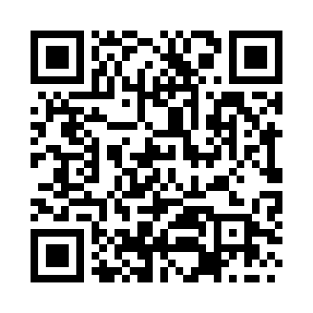

**Prayer times for Borupskov, Denmark**

**Sun 1 Sep 2024 - Mon 30 Sep 2024**

**High Latitude Method: Angle Based Rule**

**Prayer Calculation Method: Muslim World League**

**Asar Calculation Method: Hanafi**

|  |  |  |  |  |  |  |  |
| --- | --- | --- | --- | --- | --- | --- | --- |
| **Date** | **Day** | **Fajr** | **Sunrise** | **Dhuhr** | **Asr** | **Maghrib** | **Isha** |
| 1 | Sun | 4:04 | 6:27 | 1:21 | 6:01 | 8:14 | 10:27 |
| 2 | Mon | 4:07 | 6:29 | 1:21 | 5:59 | 8:11 | 10:23 |
| 3 | Tue | 4:10 | 6:31 | 1:21 | 5:57 | 8:09 | 10:19 |
| 4 | Wed | 4:13 | 6:33 | 1:20 | 5:55 | 8:06 | 10:16 |
| 5 | Thu | 4:16 | 6:35 | 1:20 | 5:53 | 8:04 | 10:12 |
| 6 | Fri | 4:19 | 6:37 | 1:20 | 5:51 | 8:01 | 10:09 |
| 7 | Sat | 4:22 | 6:39 | 1:19 | 5:49 | 7:59 | 10:06 |
| 8 | Sun | 4:25 | 6:41 | 1:19 | 5:47 | 7:56 | 10:02 |
| 9 | Mon | 4:28 | 6:43 | 1:19 | 5:44 | 7:53 | 9:59 |
| 10 | Tue | 4:30 | 6:45 | 1:18 | 5:42 | 7:51 | 9:56 |
| 11 | Wed | 4:33 | 6:46 | 1:18 | 5:40 | 7:48 | 9:52 |
| 12 | Thu | 4:36 | 6:48 | 1:18 | 5:38 | 7:46 | 9:49 |
| 13 | Fri | 4:38 | 6:50 | 1:17 | 5:36 | 7:43 | 9:46 |
| 14 | Sat | 4:41 | 6:52 | 1:17 | 5:34 | 7:40 | 9:43 |
| 15 | Sun | 4:44 | 6:54 | 1:16 | 5:32 | 7:38 | 9:39 |
| 16 | Mon | 4:46 | 6:56 | 1:16 | 5:30 | 7:35 | 9:36 |
| 17 | Tue | 4:49 | 6:58 | 1:16 | 5:27 | 7:32 | 9:33 |
| 18 | Wed | 4:51 | 7:00 | 1:15 | 5:25 | 7:30 | 9:30 |
| 19 | Thu | 4:54 | 7:02 | 1:15 | 5:23 | 7:27 | 9:27 |
| 20 | Fri | 4:56 | 7:04 | 1:15 | 5:21 | 7:25 | 9:24 |
| 21 | Sat | 4:58 | 7:06 | 1:14 | 5:19 | 7:22 | 9:21 |
| 22 | Sun | 5:01 | 7:07 | 1:14 | 5:16 | 7:19 | 9:18 |
| 23 | Mon | 5:03 | 7:09 | 1:14 | 5:14 | 7:17 | 9:15 |
| 24 | Tue | 5:05 | 7:11 | 1:13 | 5:12 | 7:14 | 9:12 |
| 25 | Wed | 5:08 | 7:13 | 1:13 | 5:10 | 7:11 | 9:09 |
| 26 | Thu | 5:10 | 7:15 | 1:13 | 5:07 | 7:09 | 9:06 |
| 27 | Fri | 5:12 | 7:17 | 1:12 | 5:05 | 7:06 | 9:03 |
| 28 | Sat | 5:15 | 7:19 | 1:12 | 5:03 | 7:04 | 9:00 |
| 29 | Sun | 5:17 | 7:21 | 1:12 | 5:01 | 7:01 | 8:57 |
| 30 | Mon | 5:19 | 7:23 | 1:11 | 4:58 | 6:58 | 8:55 |

**Prayer times provided by https://www.salahtimes.com**