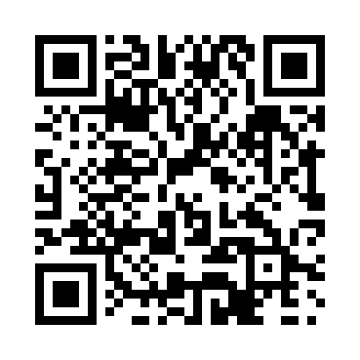
Prayer times for Collette, New Brunswick, Canada
Wed 1 May 2024 - Fri 31 May 2024
High Latitude Method: Angle Based Rule
Prayer Calculation Method: Islamic Society of North America
Asar Calculation Method: Hanafi

Date | Day | Fajr | Sunrise | Dhuhr | Asr | Maghrib | Isha
1 | Wed | 4:27 | 6:06 | 1:19 | 6:21 | 8:33 | 10:12
2 | Thu | 4:25 | 6:04 | 1:19 | 6:22 | 8:34 | 10:14
3 | Fri | 4:22 | 6:03 | 1:19 | 6:23 | 8:35 | 10:16
4 | Sat | 4:20 | 6:01 | 1:19 | 6:24 | 8:36 | 10:18
5 | Sun | 4:18 | 6:00 | 1:18 | 6:24 | 8:38 | 10:20
6 | Mon | 4:16 | 5:58 | 1:18 | 6:25 | 8:39 | 10:22
7 | Tue | 4:14 | 5:57 | 1:18 | 6:26 | 8:40 | 10:24
8 | Wed | 4:12 | 5:56 | 1:18 | 6:27 | 8:42 | 10:26
9 | Thu | 4:10 | 5:54 | 1:18 | 6:27 | 8:43 | 10:28
10 | Fri | 4:08 | 5:53 | 1:18 | 6:28 | 8:44 | 10:30
11 | Sat | 4:06 | 5:52 | 1:18 | 6:29 | 8:46 | 10:32
12 | Sun | 4:04 | 5:50 | 1:18 | 6:30 | 8:47 | 10:34
13 | Mon | 4:02 | 5:49 | 1:18 | 6:30 | 8:48 | 10:36
14 | Tue | 4:00 | 5:48 | 1:18 | 6:31 | 8:49 | 10:38
15 | Wed | 3:58 | 5:47 | 1:18 | 6:32 | 8:51 | 10:39
16 | Thu | 3:56 | 5:45 | 1:18 | 6:33 | 8:52 | 10:41
17 | Fri | 3:54 | 5:44 | 1:18 | 6:33 | 8:53 | 10:43
18 | Sat | 3:52 | 5:43 | 1:18 | 6:34 | 8:54 | 10:45
19 | Sun | 3:51 | 5:42 | 1:18 | 6:35 | 8:55 | 10:47
20 | Mon | 3:49 | 5:41 | 1:18 | 6:35 | 8:56 | 10:49
21 | Tue | 3:47 | 5:40 | 1:18 | 6:36 | 8:58 | 10:51
22 | Wed | 3:45 | 5:39 | 1:19 | 6:37 | 8:59 | 10:53
23 | Thu | 3:44 | 5:38 | 1:19 | 6:37 | 9:00 | 10:55
24 | Fri | 3:42 | 5:37 | 1:19 | 6:38 | 9:01 | 10:56
25 | Sat | 3:41 | 5:36 | 1:19 | 6:39 | 9:02 | 10:58
26 | Sun | 3:39 | 5:35 | 1:19 | 6:39 | 9:03 | 11:00
27 | Mon | 3:37 | 5:35 | 1:19 | 6:40 | 9:04 | 11:02
28 | Tue | 3:36 | 5:34 | 1:19 | 6:41 | 9:05 | 11:03
29 | Wed | 3:35 | 5:33 | 1:19 | 6:41 | 9:06 | 11:05
30 | Thu | 3:33 | 5:32 | 1:19 | 6:42 | 9:07 | 11:06
31 | Fri | 3:32 | 5:32 | 1:20 | 6:42 | 9:08 | 11:08
Prayer times provided by https://www.salahtimes.com

