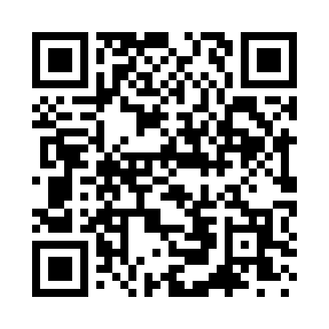
Prayer times for Alexander Beach, Washington, USA
Wed 1 May 2024 - Fri 31 May 2024
High Latitude Method: Angle Based Rule
Prayer Calculation Method: Islamic Society of North America
Asar Calculation Method: Shafi

Date | Day | Fajr | Sunrise | Dhuhr | Asr | Maghrib | Isha
1 | Wed | 4:05 | 5:50 | 1:08 | 5:08 | 8:26 | 10:11
2 | Thu | 4:03 | 5:48 | 1:08 | 5:08 | 8:28 | 10:13
3 | Fri | 4:01 | 5:47 | 1:07 | 5:09 | 8:29 | 10:16
4 | Sat | 3:58 | 5:45 | 1:07 | 5:09 | 8:30 | 10:18
5 | Sun | 3:56 | 5:44 | 1:07 | 5:10 | 8:32 | 10:20
6 | Mon | 3:54 | 5:42 | 1:07 | 5:11 | 8:33 | 10:22
7 | Tue | 3:51 | 5:40 | 1:07 | 5:11 | 8:35 | 10:24
8 | Wed | 3:49 | 5:39 | 1:07 | 5:12 | 8:36 | 10:26
9 | Thu | 3:47 | 5:38 | 1:07 | 5:12 | 8:37 | 10:29
10 | Fri | 3:44 | 5:36 | 1:07 | 5:13 | 8:39 | 10:31
11 | Sat | 3:42 | 5:35 | 1:07 | 5:13 | 8:40 | 10:33
12 | Sun | 3:40 | 5:33 | 1:07 | 5:14 | 8:41 | 10:35
13 | Mon | 3:38 | 5:32 | 1:07 | 5:14 | 8:43 | 10:38
14 | Tue | 3:35 | 5:31 | 1:07 | 5:15 | 8:44 | 10:40
15 | Wed | 3:33 | 5:29 | 1:07 | 5:15 | 8:45 | 10:42
16 | Thu | 3:31 | 5:28 | 1:07 | 5:16 | 8:47 | 10:44
17 | Fri | 3:29 | 5:27 | 1:07 | 5:16 | 8:48 | 10:46
18 | Sat | 3:27 | 5:26 | 1:07 | 5:17 | 8:49 | 10:49
19 | Sun | 3:25 | 5:24 | 1:07 | 5:17 | 8:50 | 10:51
20 | Mon | 3:23 | 5:23 | 1:07 | 5:18 | 8:52 | 10:53
21 | Tue | 3:21 | 5:22 | 1:07 | 5:18 | 8:53 | 10:55
22 | Wed | 3:19 | 5:21 | 1:07 | 5:18 | 8:54 | 10:57
23 | Thu | 3:17 | 5:20 | 1:07 | 5:19 | 8:55 | 10:59
24 | Fri | 3:15 | 5:19 | 1:08 | 5:19 | 8:56 | 11:01
25 | Sat | 3:13 | 5:18 | 1:08 | 5:20 | 8:58 | 11:03
26 | Sun | 3:13 | 5:17 | 1:08 | 5:20 | 8:59 | 11:03
27 | Mon | 3:12 | 5:17 | 1:08 | 5:21 | 9:00 | 11:04
28 | Tue | 3:12 | 5:16 | 1:08 | 5:21 | 9:01 | 11:05
29 | Wed | 3:12 | 5:15 | 1:08 | 5:22 | 9:02 | 11:05
30 | Thu | 3:11 | 5:14 | 1:08 | 5:22 | 9:03 | 11:06
31 | Fri | 3:11 | 5:14 | 1:08 | 5:22 | 9:04 | 11:06
Prayer times provided by https://www.salahtimes.com

